[1]Chapter 15  
Piezoelectric and Opto-Acoustic Material Properties of Bone

Mami Matsukawa and Atsushi Hosokawa

Abstract (about 200 words)

15.1 Introduction

Ultrasonic material characterization is usually understood as the evaluation of various materials to obtain ultrasonic wave properties, such as wave velocities, attenuation and backscatter coefficients, nonlinearity, or acoustic impedance. These properties are related to the visco-elasticity and mostly can be obtained by the measurements of elastic waves. There have been a lot of studies on the ultrasonic wave properties of bone using many techniques in various frequency ranges, as introduced in the former book (Laugier and Haïat 2011). However, as reported in [please give some references], ultrasonic wave propagation also depends on piezoelectricity and interacts with optical properties of materials. Considering bone as a living tissue, ultrasonic material characterization of such should also be related to electrical and optical properties, because a lot of bioelectric phenomena in the body occur there.

In this chapter, two different topics are addressed: piezoelectricity of bone and opto-acoustic bone evaluation. After the interesting discovery of weak bone piezoelectricity in the 1950’s, the mechanism of bone piezoelectricity has been discussed in the area of biomechanics, in a relatively low frequency range up to kHz. The recent experimental studies brought evidence that the origin of piezoelectricity is in the collagen fibers. However, relatively few studies on the piezoelectricity in bone in the MHz range have been reported, though ultrasonic waves are widely used for bone fracture therapy. Considering the background, this chapter introduces the recent studies on bone piezoelectricity in the MHz range.

The opto-acoustic evaluation is also one of the interesting topics in the area of medical ultrasonics, especially for the soft tissue evaluation. In spite of the very early discoveries of opto-acoustic phenomena, such as photoacoustic and Brillouin scattering (please add references to these early discoveries), the actual applications of these phenomena to tissue evaluation were realized only after the invention of a powerful light sources such as lasers . In this chapter, recent challenging studies on the application of these opto-acoustic techniques to bone evaluation are introduced.

15.2 Piezoelectric (Electromechanical) Effects in Low Frequency Range

Bone growth (callus formation) can be induced not only by mechanical but also electrical stimulation (Yasuda et al. 1955; Yasuda 1974), and bone can be regarded as a piezoelectric material (Fukada et al. 1957). From these facts, it has been suggested that bone remodeling can be largely affected by piezoelectric (electromechanical) properties (Bassett et al. 1971; Gjelsvik 1973; Guzelsu 1978). Therefore, it is interesting to investigate the piezoelectric (electromechanical) effects in bone.

The piezoelectric effect is the generation of electric charge by mechanical stress, and the converse piezoelectric effect is the generation of mechanical strain by electric field. The piezoelectric constitutive equations in the stress-charge form are

, (15.1a)



, (15.1b)



where *Sij* and *Tij* are the stress and strain in the *j*-direction on the *i*-plane, respectively, and *Ei* and *Di* are the electric field electric displacement in the i-direction, respectively, and *sij*, *dij* and *ij* are the compliance, piezoelectric constant, and dielectric constant, respectively.

In this section, initial studies on static and the dynamic piezoelectric effects at low frequencies in cortical bone are mainly introduced. Most of them were performed before the 2000s.

15.2.1 Discovery of Piezoelectricity in Bone

The experimental observation of the piezoelectricity in bone was first reported by Fukada and Yasuda (1957). Both direct and converse piezoelectric effects were observed by the experimental apparatus used when Fukada succeeded in observing the piezoelectric effects in wood (Fukada 1955). In the experiments, plate-shaped cortical bone specimens cut from human and bovine femur and dried were used. The static method using a lever mechanism was adopted in the experiments of the direct piezoelectric effects, while the dynamical method using a Rochelle salt piezoelectric element was adopted in both experiments of the direct and converse piezoelectric effects. In the dynamical method, the frequency was 2 kHz. The piezoelectric effects could be observed only when shear stress was applied to the collagen fibers. The experimental results are shown in Figs. 15.1(a) and 15.1(b) which show the direct and converse piezoelectric effects, respectively. From the experimental results, the matrix of the piezoelectric constant was determined as

. (15.2)



Here, the 1-direction was defined as the axial direction of the cylindrical cortical shell, along which the collagen fibers made the spiral structure, and the symmetrical properties to the axis was assumed. The maximum measured value of the piezoelectric constant *d*14 was 6  10-9 esu/dyne = 2  10-13 C/N (note that the value in the reference was given in not SI of units but cgs system), which was approximately one tenth of *d*11 of quartz. The piezoelectric response to bending stress was observed in several mammalian and amphibian long bones by Bassett and Becker (1962), and the results showed that negative electrical potentials could be generated under compression. Moreover, it was described that the results were similar to the previous ones reported by Fukada and Yasuda (1957). The magnitudes of the piezoelectric responses in human and rabbit bones were measured by Shamos et al. (1963). Then, bending and compressing stresses were applied to long and short bones, respectively.

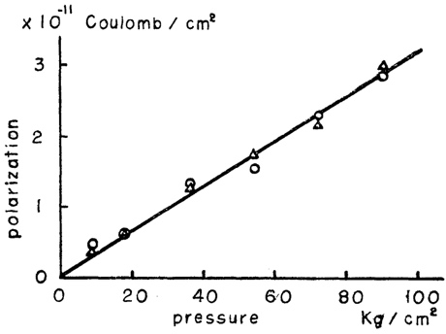

(a) Direct piezoelectric effect

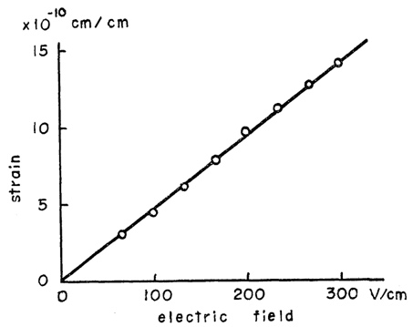

(b) Direct piezoelectric effect

**Fig. 15.1** (a) Direct and (b) converse piezoelectric effects of bone. (Reproduced from Fukada et al. 1957)

15.2.2 Origin of piezoelectricity in bone

The bone tissue is mainly composed of hydroxyapatite crystals and collagen fibers. From the facts that the occurrence of piezoelectric effects was associated with the orientation of the collagen fibers and that the piezoelectric effects remained after the hydroxyapatite crystals were completely dissolved, it was expected that the origin of the piezoelectricity in bone was not the hydroxyapatite crystals but the collagen fibers (Fukada et al. 1957). To investigate the origin of piezoelectricity in bone, the piezoelectric properties in the tendon collagen were measured (Fukada et al. 1964; Shamos et al. 1967). The piezoelectric matrix was determined as

 (15.3)



and a similar matrix was established for horse femur (Fukada et al. 1964). The measured values of the piezoelectric constants in the tendon collagen were approximately ten times larger than those in bone. On the other hand, it was shown that the piezoelectric constant d14 in bone collagen was approximately one sixth of that in tendon collagen and that the piezoelectric origin in bone could be the collagen only (Marino et al. 1971). However, the piezoelectricity in single hydroxyapatite crystals was experimentally confirmed in the recent years (Tofail et al. 2009; Lang et al. 2011). Thus, the origin of the piezoelectricity in bone remains controversial.

15.2.2 Origin of piezoelectricity in bone

To investigate the piezoelectricity in bone under physiologic moisture condition, the electromechanical properties in living and wet bones were also measured (Bassett et al. 1962; Cochran et al. 1965; Anderson et al. 1970; Bur 1976; Maeda et al. 1982; Maeda et al. 1982; Johnson et al. 1980; Gross et al. 1982; Otter et al. 1985; Hastings et al. 1991; Marino et al. 1975; McElhaney1967). The piezoelectric effects in living bones were first reported by Bassett and Becker (1962) and were similar with those in dead bones. The piezoelectric properties in both in vitro and in vivo moist bone were investigated by Cochran et al. in the same year (Cochran et al. 1965). The piezoelectric constants (for only the normal stress and strain) in dry and wet bovine bones were measured and compared by Anderson and Eriksson (1970). For dry bone the typical measured results were as follows (note that the values in the reference were given in not SI of units but cgs system);

 (15.4a)



or

. (15.4b)



The non-zero matrix elements were different from both Eqs. (15.2) and (15.3) which was attributed to the oblique oriented angle of collagen fibers. For wet bone, the measured result was as follows;

 (15.5a)



or

 (15.5b)



The piezoelectric matrix for wet bone was largely different from that for dry bone. In particular, all matrix elements for wet bone had same (positive) polarity, unlike for dry bone. The main cause of this was considered that the electrical signal could be generated by streaming potential due to the liquid in the pores. Piezoelectric properties as functions of temperature and humidity (or hydration) were investigated by Bur (1976) and Maeda et al. (1982), and the experimental results showed that the temperature dependence of the piezoelectric constants could increase with water content, which was attributed to the collagen fibers. It was suggested that two different mechanisms, piezoelectricity and streaming potential, were responsible for the electromechanical effects in dry and wet bones, respectively (Johnson et al. 1980; Gross et al. 1982; Otter et al. 1985; Hastings et al. 1991). Moreover, to reduce the conductivity, the piezoelectric constant in hydrated frozen bone was measured by Marino and Becker (1975). Note that hereinafter, the term “electromechanical effects” is used instead of “piezoelectric effects” unless clearly distinguishable.

15.2.3 Miscellaneous experiments involving the electromechanical effects

Various effects on the electromechanical properties in bone were investigated, and some of them are introduced in this section. The spatial distribution of the surface charge in a human femur under load was measured by McElhaney (1967) to investigate the variation in the electromechanical effects with the anatomical site. The electromechanical (stress-generated) responses with micrometer scale resolution were observed using a microelectrode technique by Starkebaum et al. (1979) to investigate the morphological effects. It was reported by Aschero et al. (1999) that the piezoelectric constant *d*23 in dry cow bone was independent of the anatomical site but dependent on the individuals. With a nanometer scale resolution, the normal (vertical) electromechanical responses in dry and wet human bones were observed by Halperin et al. (2004), and the shear response in dry animal bone was observed by Jolandan and Yu (2010). Moreover, the piezoelectric constants d14 in dry mature and immature bones were compared by Marino and Becker (1974) to investigate the variation with age.

15.2.4 Observation methods

The observation methods for the electromechanical effects can be roughly classified into static and dynamic methods. In the static methods for the direct electromechanical effects using a lever (Fukada et al. 1957), a piston (Cochran et al. 1965; Aschero et al. 1996), or a hydraulic fatigue testing machine (Hastings et al. 1991), the mechanical stress was applied by bending (Fukada et al. 1957; Bassett et al. 1962; Shamos et al. 1963; Cochran et al. 1965; Johnson et al. 1980; Hastings et al. 1991; Starkebaum et al. 1979) or compressing (Shamos et al. 1963). In the static method for the converse electromechanical effects, the strain was detected using a dilatometer (Aschero et al. 1999). In the dynamic methods for the direct and converse electromechanical effects using a piezoelectric element (Fukada et al. 1957; Fukada et al. 1964; Marino et al. 1971; Anderson et al. 1970; Bur 1976; Maeda et al. 1976; Maeda et al. 1982; Marino et al. 1974), the periodical stress was applied and detected, respectively. The frequencies were 2 kHz (Fukada et al. 1957; Bassett et al. 1962), 0.01-100 Hz (Bur 1976), 10 Hz (Maeda et al. 1976; Maeda et al. 1982), and 2 and 3 kHz (Marino et al. 1974). Devices were devised and specialized for bone measurement.

15.3 Piezoelectric (electromechanical) effects in the high frequency range

The ultrasound stimulation can be used for bone growth (Xavier et al. 1983; Duarte 1983, Padilla et al. 2014) and accelerated healing of bone fracture using low-intensity pulsed ultrasound (LIPUS) or sonic accelerated fracture healing system (SAFHS) at a few megahertz which has been medically practiced in recent years. To enhance fracture healing, it is important to understand the piezoelectric (electromechanical) effects in the megahertz frequency range. In this chapter, recent studies in the 2000s on the electromechanical effects at high (megahertz) frequencies in cortical and cancellous bone are introduced. In most of the studies, the electromechanical effects were observed with the bone specimens immersed in water.

15.3.1 Electromechanical effects in cortical bone

The electromechanical response generated in bone by an ultrasound wave is difficult to observe using the mechanical methods adopted in the low frequency range. Moreover, the response is so small that the effect of electromagnetic noise should be sufficiently reduced. To the best of the authors’ knowledge, the electromechanical response in cortical bone in the megahertz frequency range was first observed by Behari and Singh (1981). The observation was performed by implanting electrodes inside rabbit femur and tibia, and transmitting ultrasound wave at 1.27 MHz in the intact bone from a coupled ultrasound transducer. In the group of Matsukawa et al., using ultrasound transducers with bovine cortical bone disks as piezoelectric elements, the electromechanical (stress-induced) effects in wet bone were observed in water (Behari et al. 1981; Okino et al. 2013; Tsuneda et al. 2015; Matsukawa et al. 2017; Mori et al. 2018). The bone transducers had a coaxial structure with an outer electric-field shield, as with a general poly(vinylidene fluoride) (PVDF) ultrasound transducer. The fabrication process of bone plate samples used in the bone transducers and the photographs of the bone and PVDF transducers are shown in Fig. 15.2(a) and 15.2(b), respectively. It was shown by Okino et al. (2013) that the sensitivities of the bone transducers were around 1/1000 of a PVDF transducer from 0.5 to 2.5 MHz (Fig. 15.3) and did not depend on the orientation of hydroxyapatite crystals in bone. It was shown from the experimental results (Fig. 15.4) obtained by Tsuneda et al. (2015) that the electromechanical potential in cortical bone could vary with the water content, but the contribution from the streaming potential appeared to be little in the megahertz range. Moreover, it was suggested that the bone microstructure could affect the piezoelectric properties. The effect of structural anisotropy related to the collagen fibers and hydroxyapatite crystals was investigated by Matsukawa et al. (2017). The bone sample preparation process and the experimental system are shown in Figs. 15.5 and 15.6, respectively. The experimental results (Fig. 15.7) showed that the potentials were maximized at ultrasound angles of approximately 45° to the bone axis but were minimized at the angles parallel to the radial, tangential, and axial directions. It was shown by Mori et al. (2018), by comparing the electromechanical potentials in cortical bone before and after demineralization, that the hydroxyapatite crystals could affect the piezoelectric properties. Both direct and converse piezoelectric effects in the megahertz range were observed by Makino et al. (2020). The maximum transmitting and receiving sensitivities of the bone transducers were approximately 150 Pa/V and 6 nV/Pa, respectively. In another study, the investigation of piezoelectric anisotropy in dry cortical bone under ultrasound irradiation was attempted by Hosokawa (2017) through experiments and simulations.

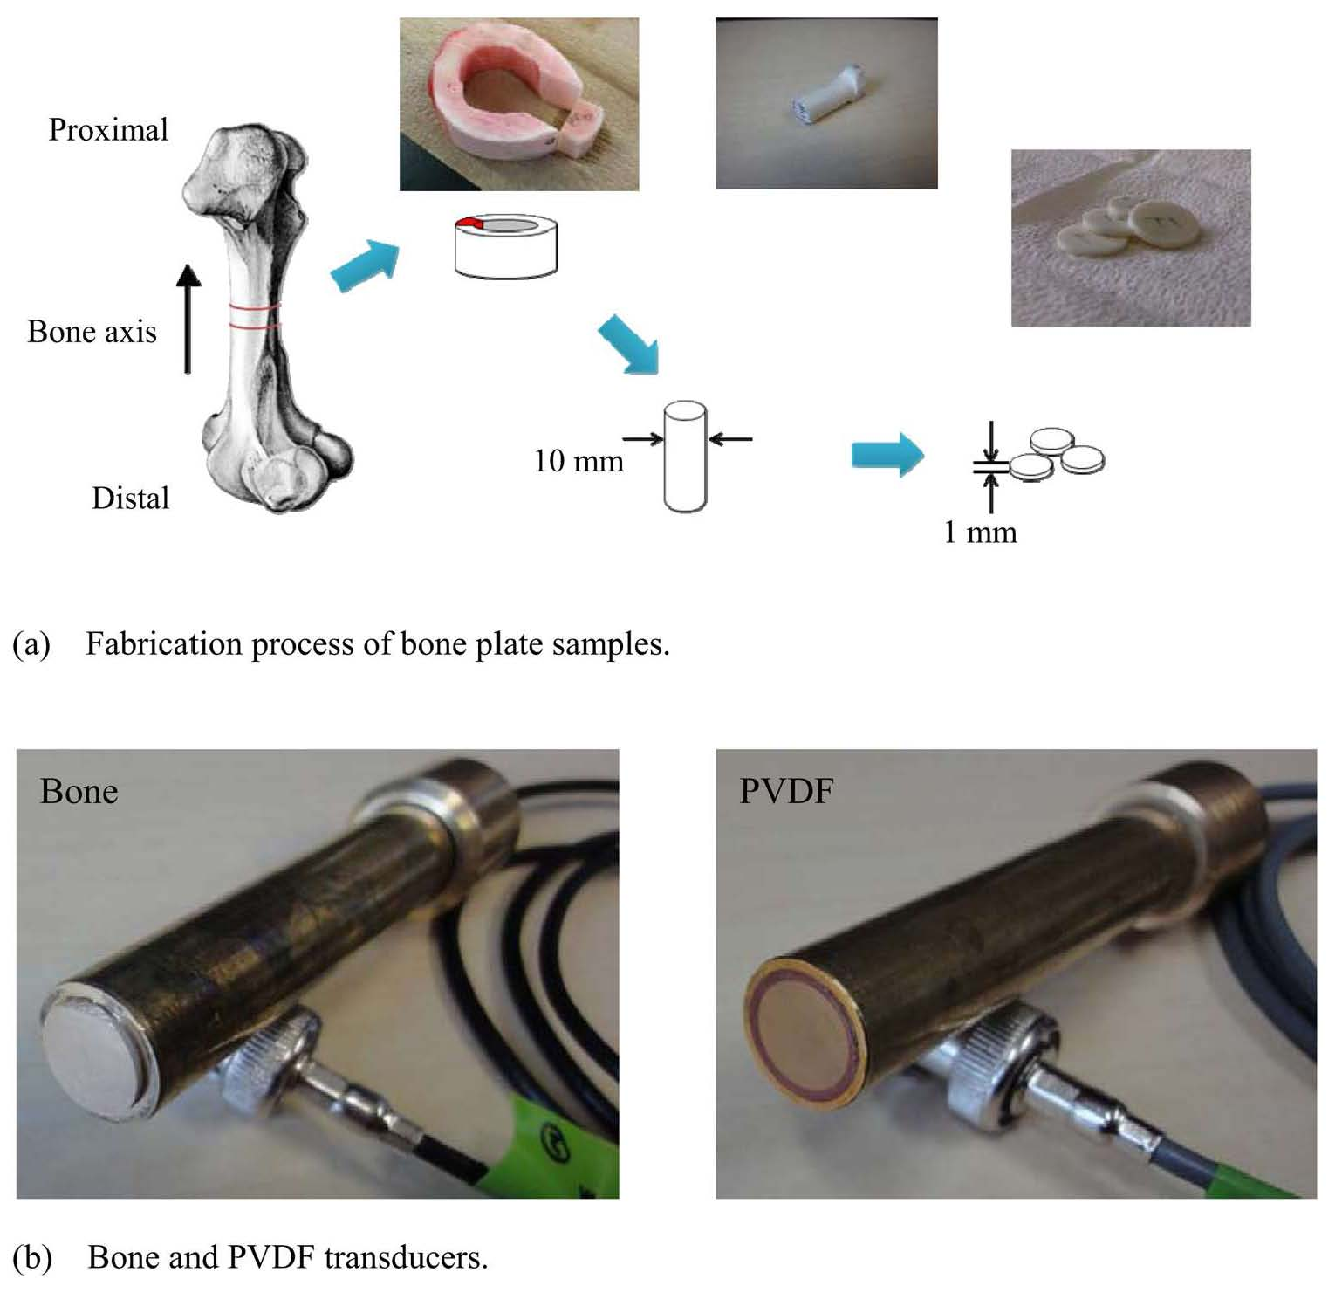

**Fig. 15.2** (a) Fabrication process of bone plate samples and (b) bone and PVDF transducers. The diameters were 10 mm, and the bone cylinder obtained from a midshaft of a bovine femur was parallel to the bone axis or bone radial directions. Therefore, the bone plate surface was normal to the bone axis or bone radial directions. (Reproduced from Okino et al. 2013)

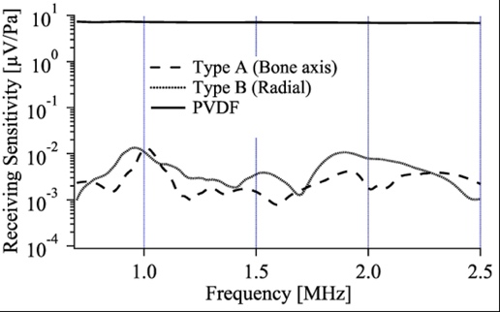

**Fig. 15.3** Typical receiving sensitivities of PVDF and Bone transducers as functions of frequency. The result of a PVDF transducer was obtained by the reciprocity calibration method. The results of bone transducers were obtained by comparative calibration with the PVDF transducer. (Reproduced from Okino et al. 2013)

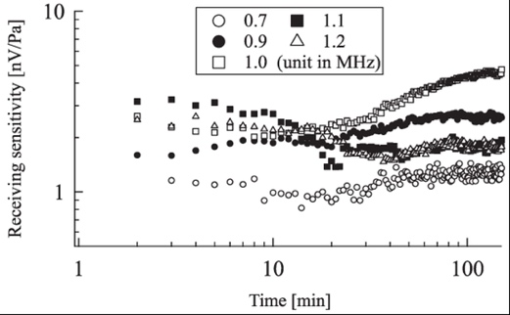

**Fig. 15.4** Typical receiving sensitivities of bone transducers as functions of immersion time. The result of bone transducers sensitivities was obtained by the comparative calibration with the PVDF transducer. (Reproduced from Tsuneda et al. 2015)

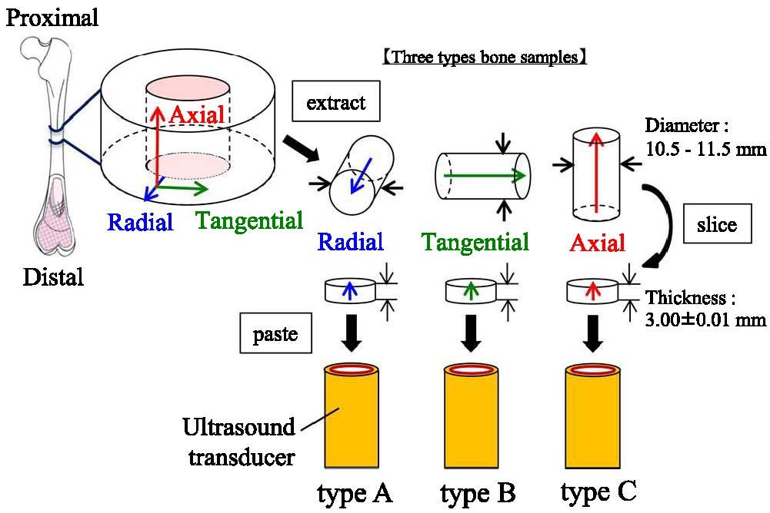

**Fig. 15.5** Bone plate sample fabrication process. Bone cylinders obtained from the mid-shaft of a bovine femur were oriented parallel to the bone radial (type A), tangential (type B), or axial (type C) directions. (Reproduced from Matsukawa et al. 2017)

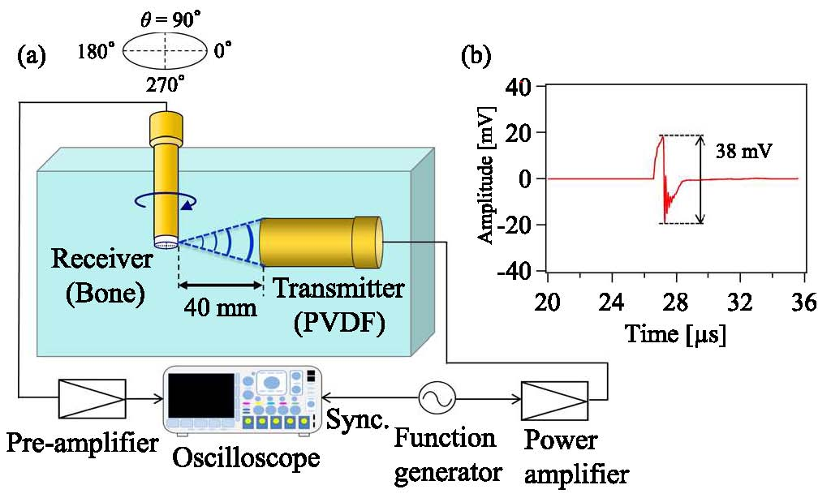

**Fig. 15.6** Diagram of the experimental system. (a) The transmitter and receiver were set to be crossed at right angles in degassed water. The bone sample’s side surface was located 40 mm from the transmitter (i.e., at the transmitter’s focal length). Ultrasound measurements were taken at each rotation angle ** from 0° to 360°. (b) Ultrasound waveform radiated by the PVDF transducer at the focus point. (Reproduced from Matsukawa et al. 2017)

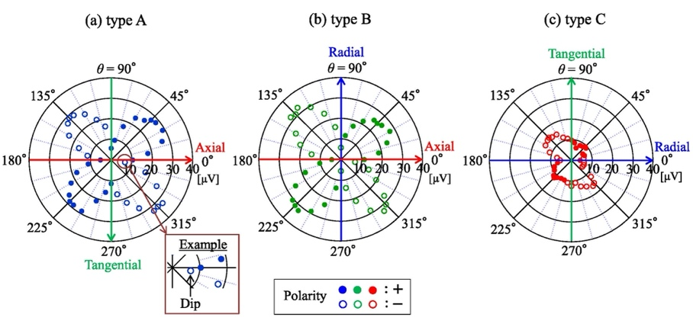

**Fig. 15.7** Relationship between the polarity and peak-to-peak values of stress-induced electric potentials and the ultrasound irradiation directions. Results were measured with (a) type A, (b) type B, and (c) type C transducers, respectively. (Reproduced from Matsukawa et al. 2017)

In the group of Ikushima et al., acoustically stimulated electromagnetic (ASEM) responses, which were detected through electromagnetic radiation induced by an ultrasound wave in various piezoelectric materials were observed in water (Ikushima et al. 2006; Ikushima et al. 2019). The schematics of the ASEM response measurement is shown in Fig. 15.8. It was reported that the ASEM response at 7.6 MHz in outer cortical bone cut from swine costae could be observed, but not the response in inner soft tissue (Ikushima et al. 2006). In this technique, the spatial distribution of the electromechanical properties can be obtained with a micrometer scale resolution (Ikushima et al. 2019). In the 2000s, studies using a piezoresponse force microscope (PFM) (Güthner et al. 1992) became active, and this apparatus has been used to measure the electromechanical properties of bone materials (Tofail et al. 2009; Lang et al. 2011; Halperin et al. 2004; Jolandan et al. 2010). Besides, the PFM can be operated to observe an electromechanical response with a nanometer scale resolution (Halperin et al. 2004; Jolandan et al. 2010).

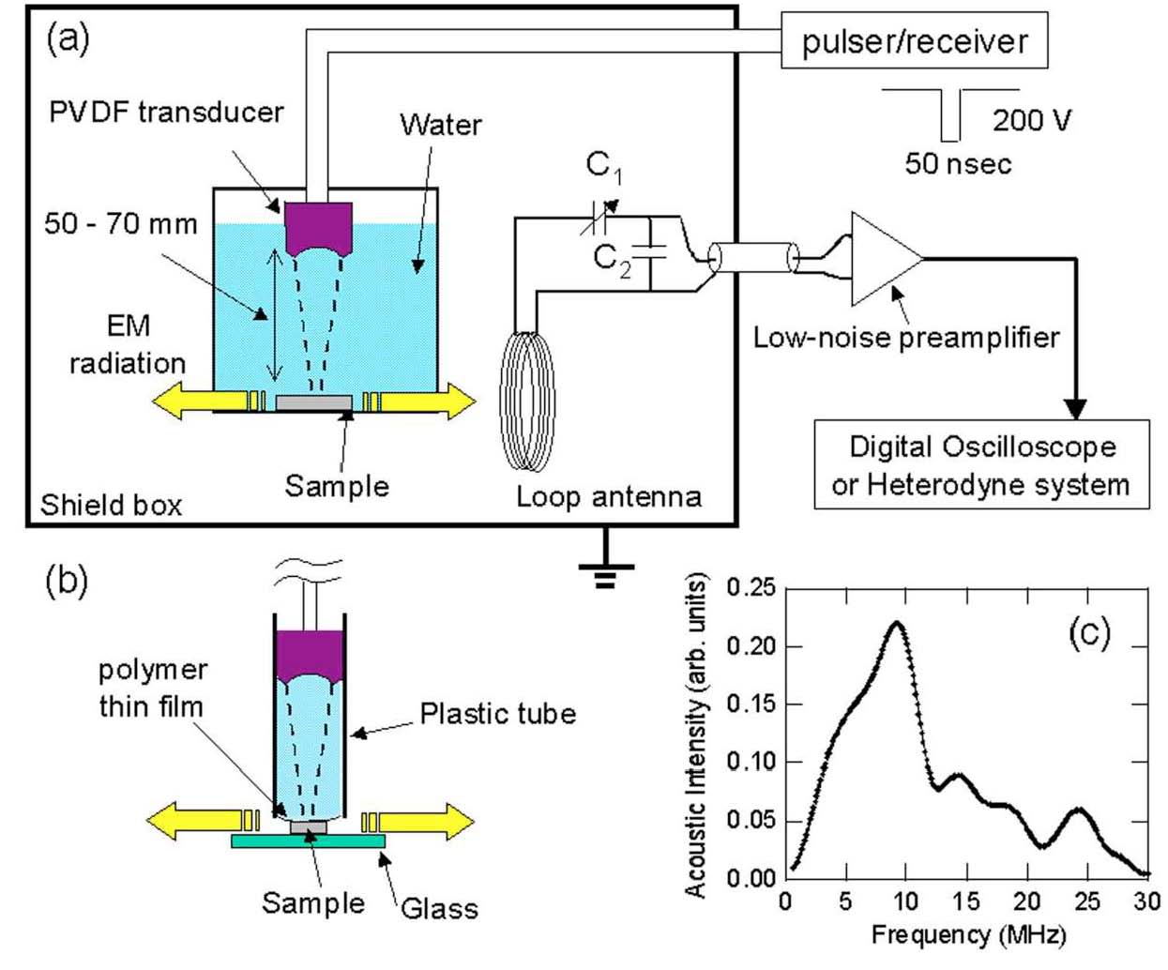

**Fig. 15.8** Schematic representation of measurements for acoustically induced EM radiation: (a) water-immersion method and (b) non-immersing probe method with a plastic tube in replace of the water tank. (c) Spectrum of ultrasound wave produced by a PVDF transducer. (Reprinted with permission from Ikushima et al. 2006)

15.3.2 Electromechanical effects in cancellous bone

To the best of the authors’ knowledge, the electromechanical response in cancellous bone was first observed at 1 MHz by Hosokawa (2016). For this observation, considering the structure of the bone transducers (see previous section), piezoelectric cells (PE-cells), in which bovine cancellous bone plates were surrounded by conductor elements, were developed. Bone marrow in the pores of the cancellous bone was removed, and the spaces were saturated with air. The photograph and the cross-sectional view of the PE-cell are shown in Fig. 15.9, and the experimental waveform received by the PE-cell is shown in Fig. 15.10. The experimental results showed that the sensitivity per unit area of cancellous bone was estimated to be below 1/100 and 1/100 000 of cortical bone and PVDF, respectively. The electromechanical response in water-saturated cancellous bone was also observed (Hosokawa 2020). Moreover, using the piezoelectric finite-difference time-domain (PE-FDTD) method, which is an elastic FDTD method with piezoelectric constitutive equations in the stress-charge form (Hosokawa 2015; Hosokawa 2016), numerical simulations of the electromechanical responses in bone were also performed by Hosokawa (Hosokawa 2017; Hosokawa 2018). The experimental and numerical results were compared to provide complementary data to each other.

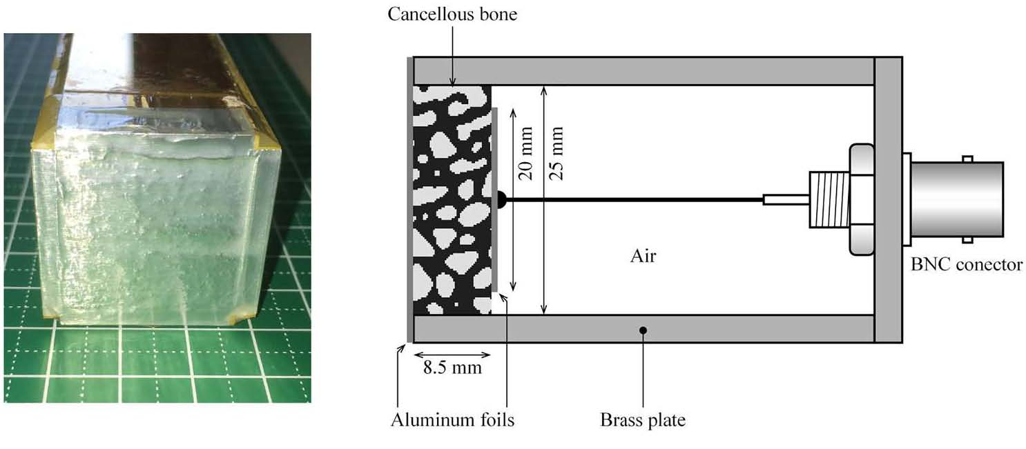

**Fig. 15.9** The photograph (left) and the cross-sectional view (right) of a prototype piezoelectric cell (PE-cell) of cancellous bone. (Reproduced from Hosokawa 2016)

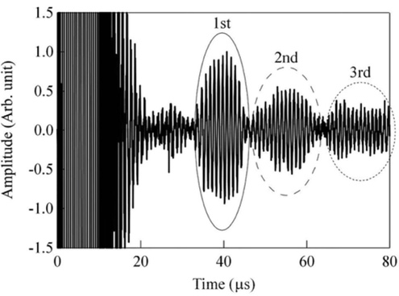

**Fig. 15.10** Experimental waveform received by the piezoelectric cell (PE-cell) of the cancellous bone specimen at a distance of 50 mm from the PZT ultrasound transmitter. The multi-reflected ultrasound waves between both surfaces of the cancellous bone specimen were observed. (Reproduced from Hosokawa 2016)

References

Anderson JC, Eriksson C (1970) Piezoelectric properties of dry and wet bone. Nature 227:491-492

Aschero G, Gizdulich P, Mango F, Romano SM (1996) Converse piezoelectric effect detected in fresh cow femur bone. J Biomech 29(9):1169-1174

Aschero G, Gizdulich P, Mango F (1999) Statistical characterization of piezoelectric coeffcient d23 in cow bone. J Biomech 32(6):573-577

Bassett CAL, Becker RO (1962) Generation of electric potentials by bone in response to mechanical stress. Science 137:1063-1064

Bassett CAL (1971) Biophysical principles affecting bone structure. In: Bourne G (ed) The Biochemistry and Physiology of Bone, Academic Press, New York, pp 1-76

Behari J, Singh S (1981) Ultrasound propagation in 'in vivo' bone. Ultrasonics 19(2):87-90

Bur AJ (1976) Measurements of the dynamic piezoelectric properties of bone as a function of temperature and humidity. J Biomech 9(8):495-507

Cochran GVB, Pawluk RJ, Bassett CAL, Electromechanical characteristics of bone under physiologic moisture conditions. Clin Orthop Relat Res 58:249-270

Duarte LR, The stimulation of bone growth by ultrasound. Arch Orthop Trauma Surg 101:153-159

Fukada E (1955) Piezoelectricity of Wood. J Phys Soc Jpn 10:149-154

Fukada E, Yasuda I (1957) On the piezoelectric effect of bone. J Phys Soc Jpn 12(10):1158-1162

Fukada E and Yasuda I (1964) Piezoelectric effects in collagen. Jpn J Appl Phys 3(2):117-121

Gjelsvik A (1973) Bone remodeling and piezoelectricity – I. J Biomech 6(2):69-77

Gross D, Williams WS (1982) Streaming potential and the electromechanical response of physiologically-moist bone. J Biomech 15(4):277-295

Güthner P, Dransfeld K (1992) Local poling of ferroelectric polymers by scanning force microscopy. Appl Phys Lett 61(9):1137-1139

Guzelsu N (1978) A piezoelectric model for dry bone tissue. J Biomech 11:257-267

Halperin C, Mutchnik S, Agronin A, Molotskii M, Salai M, Rosenman G (2004) Piezoelectric effect in human bones studied in nanometer scale. Nano Lett 4(7):1253-1256

Hastings GW, Mahmud FA (1991) The electromechanical properties of fluid-filled bone: A new dimension. J Mater Sci Mater Med 2(2):118-124

Hosokawa A (2015) Numerical simulation of piezoelectric effect of bone under ultrasound irradiation. Jpn J Appl Phys 54:07HF06

Hosokawa A (2016) Experimental observation of piezoelectric effect in cancellous bone generated by ultrasound irradiation. J Acoust Soc Am 140(5):EL441-EL445

Hosokawa A (2016) Numerical simulation of piezoelectric effect under ultrasound irradiation with consideration of conductivity. Jpn J Appl Phys 55:07KF03

Hosokawa A (2017) Investigation of piezoelectric anisotropy of bovine cortical bone at an ultrasound frequency by coupling an experiment and a simulation. J Acoust Soc Am 142(2):EL184-EL189

Hosokawa A (2018) Observations of experimental and numerical waveforms of piezoelectric signals generated in bovine cancellous bone by ultrasound waves. Jpn J Appl Phys 57:07LF06

Hosokawa A (2020) Change of piezoelectric signal in cancellous bone with ultrasound irradiation angle. Jpn J Appl Phys 59:SKKE03

Ikushima K, Watanuki S, Komiyama S (2006) Detection of acoustically induced electromagnetic radiation. Appl Phys Lett 89(19):194103

Ikushima K, Kumamoto T, Ito K, Anzai Y (2019) Electric polarization of soft biological tissues induced by ultrasound waves. Phys Rev Lett 123(23):238101

Johnson MW, Chakkalakal DA, Harper RA, Katz JL (1980) Comparison of the electromechanical effects in wet and dry bone. J Biomech 13(5):437-442

Jolandan MM, Yu MF (2010) Shear piezoelectricity in bone at the nanoscale. Appl Phys Lett 97:153127

Lang SB, Tofail SAM, Gandhi AA, Gregor M, Wolf-Brandstetter C, Kost J, Bauer S, Krause M (2011) Pyroelectric, piezoelectric, and photoeffects in hydroxyapatite thin films on silicon. Appl Phys Lett 98:123703

Maeda H, Tsuda K, Fukada E (1976) The dependence on temperature and hydration of piezoelectric, dielectric and elastic constants of bone. Jpn J Appl Phys 15(12):2333-2336

Maeda H, Fukada E (1982) Effect of water on piezoelectric, dielectric, and elastic properties of bone. Biopolymers 21(10):2055-2068

Makino T, Nakamura T, Bustamante L, Takayanagi S, Koyama D, Matsukawa M (2020) Piezoelectric and inversely piezoelectric responses of bone tissue plates in the megahertz range. IEEE Trans Ultrason Ferroelectr Freq Control 67(8):1525-1532

Marino AA, Becker RO, Soderholm SC (1971) Origin of the piezoelectric effect in bone. Calcif Tissue Res 8(1):177-180

Marino AA, Becker RO (1974) Piezoelectricity in bone as a function of age. Calcif Tissue Res 14(1):327-331

Marino AA, Becker RO (1975) Piezoelectricity in hydrated frozen bone and tendon. Nature 253:627-628

Matsukawa S, Makino T, Mori S, Koyama D, Takayanagi S, Mizuno K, Yanagitani T, Matsukawa M (2017) Effect of anisotropy on stress-induced electrical potentials in bovine bone using ultrasound irradiation. Appl Phys Lett 110(14):143701

McElhaney JH (1967) The charge distribution of the human femur due to load. J Bone Joint Surg 49-A(8):1561-1571

Mori S, Makino T, Koyama D, Takayanagi S, Yanagitani T, Matsukawa M (2018) Ultrasonically-induced electrical potentials in demineralized bovine cortical bone. AIP Adv 8(4):0450007

Okino M, Coutelou S, Mizuno K, Yanagitani T, Matsukawa M (2013) Electrical potentials in bone induced by ultrasound irradiation in the megahertz range. Appl Phys Lett 103(10):103701

Otter M, Shoenung J, Williams W (1985) Evidence for different sources of stress-generated potentials in wet and dry bone. J Orthop Res 3(3):321-324

Padilla F, Puts R, Vico L, Raum K. (2014) Stimulation of bone repair with ultrasound: A review of the possible mechanic effects. Ultrasonics 54(5):1125-45

Shamos MH, Lavine LS, Shamos MI (1963) Piezoelectric effect in bone. Nature 5:81

Shamos MH, Lavine LS (1967) Piezoelectricity as a fundamental property of biological tissues. Nature 213:267-269

Starkebaum W, Pollack SR, Korostoff E (1979) Midroelectrode studies of stress-generated potentials in four-point bending of bone. J Biomed Mat Res 13(5):729-751

Tofail SAM, Haverty D, Cox F, Erhart J, Hána P, Ryzhenko V (2009) Direct and ultrasonic measurements of macroscopic piezoelectricity in sintered hydroxyapatite. J Appl Phys 105(6):064103

Tsuneda H, Matsukawa S, Takayanagi S, Mizuno K, Yanagitani T, Matsukawa M (2015) Effects of microstructure and water on the electrical potentials in bone induced by ultrasound irradiation. Appl Phys Lett 106(7):073704

Xavier CAM, Duarte LR (1983) Ultrasonic stimulation of bone callus: Clinical applications. Rev Brasileira Orthp 18(3):73-80

Yasuda I, Noguchi K, Sata T (1955) Dynamic callus and electric callus. J Bone Joint Surg 37-A:1292-1293

Yasuda I (1974) Mechanical and electrical callus. Ann NY Acad Sci 238(1):457-465

## *15.4 Opto-acoustic evaluation of bone*

## The interaction between light (electromagnetic wave) and ultrasound (phonon) can also give us information of material properties, such as elasticity and refractive index. Using non-contact systems, most of opto-acoustic techniques enable measurements more easily than the conventional ultrasonic pulse techniques, which need gels or water as the contacting medium. The maneuverability of beam focusing and targeting of light can also achieve high-resolution microscopic imaging of materials. However, compared to the progress of studies on soft tissues, the application of optical-acoustical technique to bone evaluation is not yet widely spread, because of its complicated and opaque characteristics. This part of the section is a small introduction to the studies on two characteristic opto-acoustical techniques, photoacoustic spectroscopy and Brillouin scattering spectroscopy, which have been applied to bone studies in the recent decades. It might be quite unusual to summarize these two techniques in one category of the opto-acoustical evaluation, because the principles (and even measurement systems) are totally different except for the use of laser beams. The former technique includes energy conversion from light to ultrasound. In most cases, the generated ultrasonic waves are then measured using an ultrasonic receiver. On the contrary, the latter does not involve any ultrasonic techniques and only measures very weak inelastic scattered light between photon and phonon in a medium, using an interferometer [49] or a virtually imaged phased array [50-51]. However, both spectroscopy techniques have some common background. They have long histories of more than 100 years and their actual application to biological materials has accelerated after the rapid development of laser techniques.

## 15.4.1 Photoacoustic evaluation of bone

The photoacoustic (PA) effect was first reported by Bell in 1880. He observed that audible sound was produced by irradiating the chopped sunlight to an optically absorbing material [52]. The PA effect refers to the generation of acoustic (ultrasonic) waves due to the absorption of electromagnetic (EM) energy in a medium mainly by using modulated or pulsed light (photons). There are a lot of reviews on conventional PA techniques which have been applied in various scientific areas, such as physics, chemistry and engineering [53-54]. PA studies renewed most specially after the developments of intense light sources such as lasers and lamps, and highly sensitive detection techniques [55]. In PA spectroscopy, a substance is scanned by an optical excitation beam in different wavelengths, and then, an absorption spectrum is obtained that corresponds to its characteristic ultrasonic (acoustic) response. In PA generation, modulation of excitation source is necessary. It is generally achieved by the pulsed modulation or continuous wave modulation of the intensity or wavelength. Thella et al. confirmed in their simulation study [56] and pointed out that PA techniques might be applied to the non-invasive diagnosis for both cortical and cancellous bones.

One initial study on a biological material was the PA spectroscopy conducted by Rosencwaig in the Bell Telephone Laboratory, who reported the photoacoustic spectra of whole blood, red blood cells and extracted hemoglobin [57, 58]. The PA spectroscopy technique has been mostly applied to soft tissues in the medical field [59], however, it is very interesting to find applications to bone studies in the first decade of 21st century. Lomei Meja et al have evaluated fracture bone callus at different stages of bone consolidation using photoacoustic microscopy in the range of 350 to 850 nm [60]. They used twenty Wistar male rats with a 3 to 5 mm incision in medial cranium, in the tibia distal third. Every 6 days, they measured the optical absorption spectra of the fractured bone with blood and bone callus, and obtained the characteristic absorption of hemoglobin. In addition to the hemoglobin, small absorption by p-Nitrophenylphosphetase was also reported in the range of 402-412 nm which decreased as the bone callus was growing. This phenomenon was also confirmed in a fractured bone when the bone consolidation was accelerated by laser radiation healing [61]. The mainstream of PA studies on soft tissues gradually shifted to PA imaging, which used short laser or RF pulse for the excitation of ultrasonic waves in the MHz range [62]. Essentially, they are electromagnetic (EM) energy in the optical (from visible to near-IR) and rf regions, which can provide high contrast and adequate penetration depth in soft tissues. Due to the absorption of a short EM pulse, the thermoelastic expansion in the tissue causes transient pressure distribution which acts as the initial source of the ultrasonic waves. The generated ultrasonic waves reach the surface of the tissue with various time delays, which are measured by the ultrasound receivers around the tissue. The observed signals at the receivers were then used to determine the initial source distribution that maps properties of the EM energy absorption. If the sample is a simple layered medium, the detected PA signal reflects the light energy deposition profile as a function of the depth. Then, the PA signal in the time domain gives us depth-dependent light absorption information of the sample, such as the depth structure and properties. However, if the tissue has more complicated structures, a more complex imaging method such as PA tomography (PAT) is preferred. Then, the tissues which are optically inhomogeneous, but ultrasonically homogeneous, are adequate. It means that the anisotropic and heterogeneous bone tissues are difficult samples for PAT. However, in case of the applications of PAT and optoacoustic brain microscopy applications to the brain tumor, interrogation of soft tissue behind a bone (optical discontinuity) becomes important [63, 64]. The major challenge of PAT to the human brain is the phase distortion due to the skull. Correcting the distortion is believed to be a tractable problem [65].

The early photoacoustic imaging of hard tissue (tooth) was attempted [66], using near-infrared nanosecond repetitive laser pulses. Their target is the diagnosis and visualization of the early stage human oral diseases such as gingivitis and tooth decay. By the comparison of the B-scan images obtained from healthy and diseased teeth, they showed comparatively high amplitude signals from stains and diseased parts were observed. The data were also analyzed as a 3D image of the distribution of dental caries (Fig.15.11). Sampathkumur et al. constructed for photoacoustic imaging and detection of early-stage dental caries using a frequency doubled Nd:YAG pulsed laser and a CW laser with path-stabilized Michelson interferometer [67]. However, it was still difficult to achieve PA imaging of bones with complicated structure.

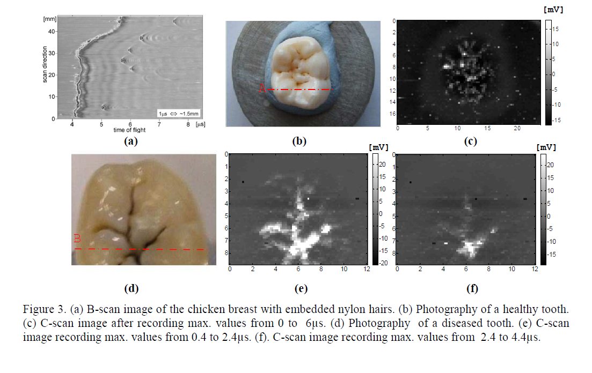

**Fig.15.11** (a)B-scan image of the chicken breast with embedded nylon hairs. (b) Photography of a healthy tooth. (c) C-scan image after recording max. values from 0 to 6 s. (d) Photography of a diseased tooth. (e) C-scan image recording max. values from 0.4 to 2.4 s. (f) C-scan image recording max. values from 2.4 to 4.4 s. (waiting the permission from Ref. [66] copyright (2010), IOP)

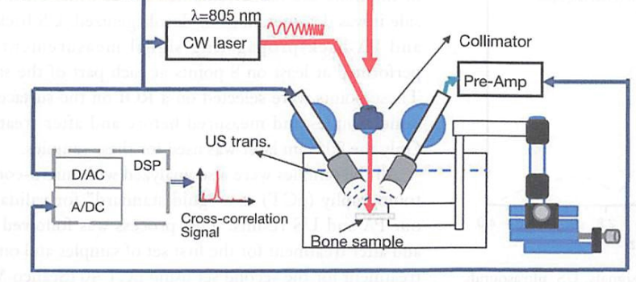

**Fig. 15.12** (a) Block diagram of combined (“coregistration”) photoacoustic (PA) and ultrasound (US) experimental set-up. (b) (Reprinted with permission from Ref. [68] copyright (2012), SPIE)

One interesting study is the combined PA and US techniques performed by Lashkari et al [68-69]. The experimental setup is shown in Fig. 15.12, which enables separate PA and US tests on bone samples. In the PA experiments the optical excitation was generated by a CW 800-nm laser source, which achieved maximum penetration depth in bone tissue in the near-IR region. The laser intensity was controlled by the linear frequency modulation chirps whose bandwidth was adjusted according to the ultrasonic transducer. Here, the PA signal detection system was used to align the focal points of both ultrasonic transducers on the same spot. Their purpose was to investigate the applicability of PA to both cortical and cancellous bones, in addition to the evaluation of bone mineral concentration. As a result, the photoacoustic and ultrasonic cross-correlation signals were both observed. This was possible with PA signals in vitro from below a thin layer of cortical bone as well as a few millimeters of trabecular bone. Relatively higher optical scattering and acoustic attenuation in bone limited the PA penetration in deep hard tissue. Measurements on a trabecular human bone show that coherent backscattering can affect PA signals in a manner similar to US.

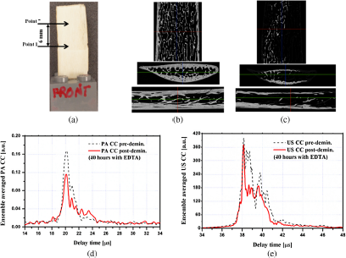

**Fig. 15.13** (a) A goat rib sample with measurement region, points 1 to 7, shown between arrows. Three μCT slice images of the goat bone in three orientations: (b) before and (c) after 40-h demineralization with EDTA solution. The ensemble averaged over the 7 points (d) PA and (e) US envelope cross-correlation signals before and after 40-h demineralization. (Reprinted with permission from Ref. [69] copyright (2014), SPIE).

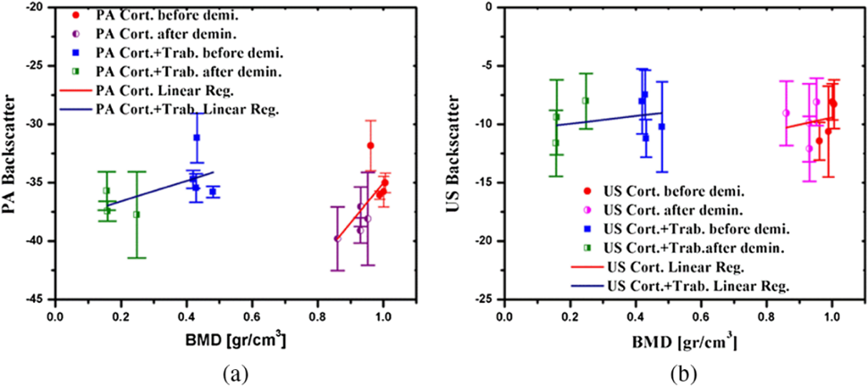

**Fig.15.14** The integrated (a) PA and (b) US-backscattered signals of cortical and combined cortical and trabecular bone versus BMD of volume of interest as obtained from μCT analysis. (Reprinted with permission from Ref. [69] copyright (2014), SPIE).

Here, it should be noted that the human cancellous bone sample used lost its marrow and had reduced lipid elements after the cleaning procedure. The PA and US signals also showed the effects of demineralization of bone with EDTA solution (Fig.15.13). They also discussed on the integrated PA and US backscattered signals of cortical bone sample and cortical + cancellous bone sample as a function of BMD from micro CT analysis. As shown in Fig. 15.14, the linear regressions of the measurements show the degree of correlation and sensitivity of PA and US to changes in bone density in the cortical and cancellous regions. Comparison of the slope of the regression lines demonstrates the higher sensitivity of PA to BMD variations in the cortical part.

Yang and Lashkari afterwards tried to perform photoacoustic and ultrasound imaging of cancellous bone using the same system and provided insights into PA and US modalities. In both PA and US results, apparent integrated backscatter (AIB) and normalized apparent backscattered (NAB) values decreased with demineralization (decreases in BV/TV), however they exhibited opposite trends with changes in collagen content. PA signals were more sensitive than US signals to those changes. In addition, PA signals showed opposite tendency compared to US signals. US signals increased while PA signals decreased with decreasing collagen content. This can be understood by considering the different responses to reduction of collagen content by the two modalities: the US backscattering is affected by a decrease in attenuation, whereas the PA back propagation is affected by the reduction in chromophore (absorber) density [70, 71].

Two new PA approaches were reported in 2015, by Feng et al [72-74]. One is photoacoustic spectral analysis to qualitatively evaluate microstructures. As shown Fig.15.15 (A), a Nd:YAG laser (685 nm, 19.2 mJ/cm2) was used to provide laser pulses with a pulse width of 5.5 ns and 2 mm in diameter. The bone surface generates PA signals which were received by a 20 MHz focused transducer. An example of PA signal from a rat femur is shown in Fig.15.15 (B). These A-mode time domain data include both signals from the inner cancellous bone and the outer cortical layer. Here, the direction of light illumination and the direction of PA signal detection were arranged with an angle larger than 90 degrees to separate the PA signal of the inner cancellous part from that of the surface cortical bone. As can be seen in Fig.17, a strong PA signal from the cortical bone at the light illuminated side arrived at the transducer later than the PA signal from the trabecular part.

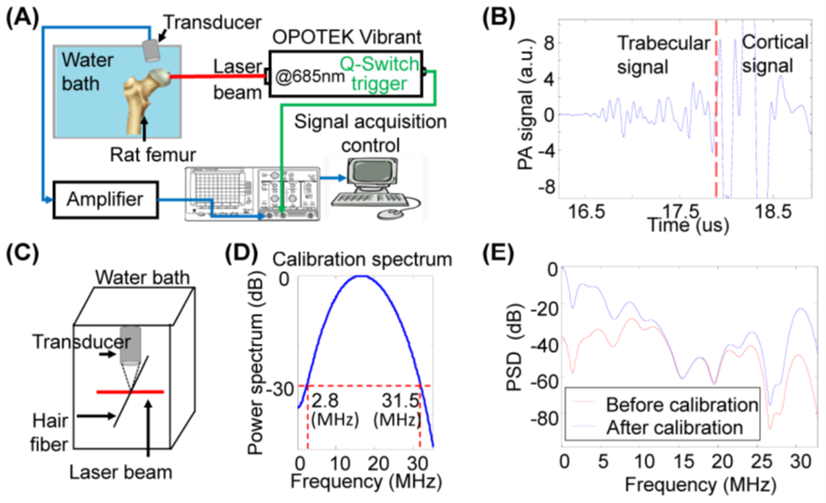

**Fig. 15.15** (A) Experimental setup for PA measurement of bone. (B) Typical RF PA signals from a rat femur. Trabecular signal and cortical signal was distinguished base on the time flight. (C) Geometry for measuring the RF PA signal from a thin hair fiber (i.e. a point source) to be used for calibration. (D) Power spectrum of the PA signal from the point source that was used later in calibrating the PA measurement from each bone specimen. (E) Power spectra density (PSD) of the trabecular signal in (b) before and after calibration. (Reprinted with permission from Ref. [73] copyright (2015), The Optical Society)

Fig.15.16 shows the ROI of the signal (trabecular part) and the calibrated PA power spectral density (PSD). They used three groups of rats subjected to 1) ovariectomy-induced bone loss (OVX, N=4), 2) preservation of bone mass with Zoledronic Acid (OVX+ZOL, N=4), and 3) normal controls (Sham, N=4). OVX, OVX+ZOL, and Sham groups were ex vivo bone specimens with low, high, and normal BMD, respectively. Fig.15.16 (B) shows the best-fit slopes by using least-square method. In comparison with the sham control (normal), the power spectrum from the OVX bones containing less and thinner trabeculae had stronger high frequency components; while the OVX+ZOL bones containing higher amount and thick trabeculae showed weaker high frequency components. The quantified slope for the three groups of bone specimens are compared in Fig.15.16(C), which demonstrates that the osteoporosis bones (OVX) had larger slope. A clinical feasibility study has started using an in vivo experimental setup [75].

The other technique suggested by the same group is thermal photoacoustic measurement (TPAM). Focusing on the temperature dependence of the Grueneisen parameter which affects the PA signal amplitude, temperature dependence of PA signal from rat samples was obtained. The idea comes from the different temperature characteristics of organic materials and non-organic minerals, and suggests that bones with different BMD should also show different TPAM outcomes. The averages and the standard deviations of the quantified TPAM slopes were 1.91 ± 0.62% / ºC, 0.36 ±0.48% / ºC, and -0.23 ± 0.13 % / ºC for OVX, Sham, and OVX+ZOL groups, respectively. The result in Fig. 15.17 (H) shows that the TPAM slope was higher for bone specimen with lower BMD.

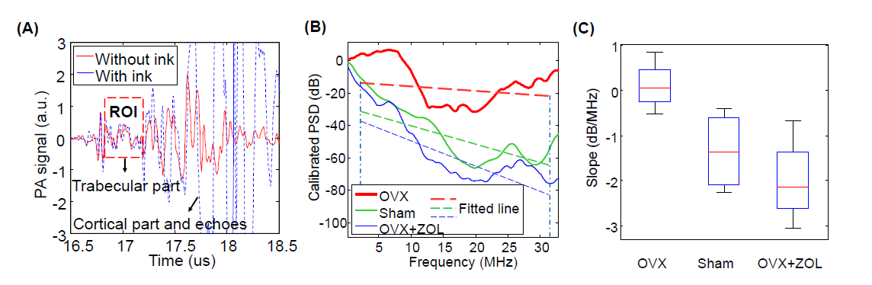

**Fig.15.16** PASA of rat femur specimens. (A) Typical PA signals from a rat femur. The marked region of interest (ROI) is from the trabecular part of the bone. (B) Examples of power spectrum of the RF PA signal from three groups (OVX, Sham, OVX+ZOL) after calibration by removing the system response. The corresponding linear fit [2.8-31.5 MHz] leads to quantified spectral parameter slope. (C) The quantified spectral parameter slope of the three groups of bones. (Reprinted with permission from Ref. [74] copyright (2015), SPIE)

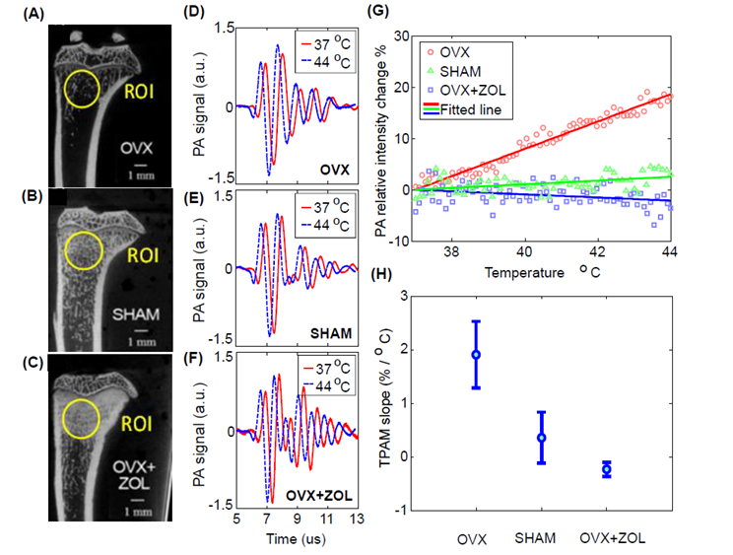

**Fig. 15.17** MicroCT images and TPAM results from rat tibia with different BMD. (A), (B) and (C) MicroCT images of the tibia of female rats subject to OVX, sham, and OVX+ZOL respectively. OVX induces a 49% reduction in trabecular BMD, while in OVX+ZOL BMD increases by 26% compared to sham controls. (D), (E) and (F) PA signals of OVX, SHAM, OVX+ZOL samples at 37 ºC and 44 ºC, respectively, (with 0.2-μs delay in order to show the change clearly). (G) TPAM lines from the measurements of three groups of rat tibia bones (OVX with low BMD, sham with normal BMD, and OVX+ZOL with high BMD). (H) Quantified TPAM slopes for the three groups (OVX, Sham, and OVX+ZOL). (Reprinted with permission from Ref. [74] copyright (2015), SPIE)

One different PA approach to evaluate bone quantitatively is the measurement of guided waves in cortical bone using axial transmission. The reader is advised to refer to the axial transmission chapter in this book for a detailed presentation of axial transmission. Moilanen et al., have combined PA excitation with skeletal quantitative ultrasound (QUS) for the assessment of long bones (PA-QUS) [76, 77]. The target is the fundamental flexural guided wave (FFGW) in axial transmission, which is analogous in curved layers to the fundamental anti-symmetric Lamb mode (A) in plate. This wave mode can be used to accurately predict cortical thickness [78]. However, the QUS measurement of FFGW in vivo is challenging because the signal should be excited and detected through the overlying soft tissue and because soft tissue affects the FFGW mode in several ways [79]. The first phantom experiments showed that PA-QUS significantly improved the detectability of FFGW, because the PA source can generate sound inside the tissue. Solid axisymmetric tubes were then measured (composites of aluminum oxide powder and epoxy, covered by silicone elastomer as the soft tissue). A pulsed Nd:YAG laser operating at 1064 nm provided photo­acoustic excitation of ultrasound signals (Fig. 15.18). A slit was used to shape the beam so as to produce a circular source of 10-mm diameter in the sample. The optical exposure generated by each 5- ns pulse emitted at a 20-Hz repetition rate was 80 mJ/ cm2. The resulting ultrasonic response was detected with distances of 20-50 mm by translating the source by a custom-made heterodyne interferometer featuring a sub-nanometer displacement resolution used as a receiver. The distance between the source and the receiver was varied by translating the source, thus allowing measurements at various distances of separation between the source and the receiver. The system then permits a full non-contact ultrasound assessment.

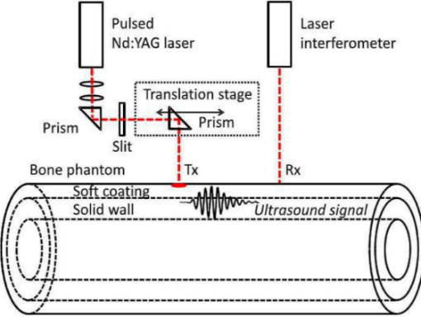

**Fig 15.18.** Experimental setup for photo-acoustic quantitative ultrasound measurements. (Reprinted with permission from Ref. [77] copyright (2014), Elsevier)

Authors have optimally excited the low frequency FFGW at less than 30 kHz, which was difficult to excite using a conventional piezoelectric transducer. Fitting the experimental phase velocity to that of the FFGW mode yielded a thickness estimate that agreed well with the true wall thickness. The RMS deviation was 0.23±0.11 mm (7.3±2.1 % ), and the RMS CV was 6.0±3.7% (5-mm coating). The studies were performed using axisymmetric phantoms which do not cause the geometric damping and mode conversion that can be expected with an irregularly shaped bone. However, the PA source was capable to efficiently generate ultrasound inside the tissue，thus avoiding problems related to acoustic coupling. Moreover, PA-QUS permits a non-contact ultrasound assessment, which is advantageous in a clinical setting because no physical contact between the probe head and the patient is needed.

Steinberg et al. also tried to investigate cortical bone with comparatively inexpensive directly-modulated fiber coupled Laser Diodes (LDs) [80,81]. Their work demonstrates the ability of multispectral PA quantitative sensing to provide both molecular information from the bone absorption spectrum, and bone mechanical status from clinically acceptable acoustic parameters (speed of sound SOS and broadband ultrasonic attenuation BUA) following the axial transmission basis. Excitation was performed optically via a portable triple laser-diode system (650, 760, and 1064 nm) and acoustically via a single element transducer. Additional dual transducers were used for detecting the acoustic waves that were generated by the two modalities. Here, both temporal and spectral parameters were compared between different excitation wavelengths and measurement modalities. The two modalities measured the same physical parameters, specifically, SOS and BUA. The maximal spot diameter was about 4 mm on the bone surface at all wavelengths. Ultrasonic excitation was performed by a 0.5 MHz single element ultrasonic immersion transducer. For both modalities, the same tone burst modulation was used to excite acoustic signals at the bone distal end (0.35 MHz central frequency and 14 μs).

From both photoacoustic and ultrasonic measurements, the first arriving signal (FAS) was identified as the first signal peak and the SOS of the FAS was defined considering the acoustic path from the source to the detector. Between, PA and QUS modalities, there exist some notable differences. The SOS measured by QUS is much higher than the SOS measured by PA. SOS depended on the wavelength in PA measurements the lower the wavelength, the higher the SOS. To understand this result we should note that the QUS FAS mostly propagates in the cortical layer near the bone surface where the acoustic path is the shortest and the SOS is the highest. In addition, the PA effect depend on the wavelength. The PA effect at 650 nm was restricted to the superficial cortical layer due to higher optical absorption and scattering at this wavelength. On the other hand, the tendency of longer wavelengths to penetrate deeper into the bone was shown. At longer wavelengths, the acoustic waves were generated more internally in cortical bone (and thus might follow a different acoustic path compared to waves generated at low wavelength) where the density (and consequently the SOS) was lower [81].

This group has recently developed a prototype device for in vivo measurements of human tibiae using a short pulse signal (400 ns) with wavelengths of 910 and 975 nm obtained using fiber coupled pulsed laser diodes [82]. Their final purpose was to achieve both QUS and PA at the bedside for an early detection and monitoring of disease progression and response to therapies. They reported the comparatively large measurement errors and the difference of SOS values between PA and US modalities, which might have resulted from the different propagation modes. They reported also the effects of blood concentration in marrow on PA signal generation and showed that the marrow content is reflected by the ratio of PA signal energies at two different wavelengths. As shown by ex vivo studies, the lower the fat contents in the marrow is, the higher the ratio of energies will be. Actually, a clear decrease in the PA energy ratio was found with age, which could potentially be exploited for the diagnosis of osteoporosis because an increase in the bone marrow fat can serve as an early indication of osteoporosis several years prior to decrease of BMD [83].

Most recent studies on the application of PA techniques to bone diagnosis involve photoacoustic imaging. Shubert and Bell applied PA techniques to image the human vertebra, especially the pedicles to guide spinal fusion surgery [84]. Focusing on the different characteristics of cortical and cancellous bones, they found that the signals from cortical bone appeared as high-amplitude signals, while signals from cancellous bone had lower amplitude, particularly at deeper depths (i.e. 3–5cm). Photoacoustic Microscopy (PAM) is also a growing modality that provides volumetric images with potential to investigate bone microstructure [85]. The spatial resolution was not enough for the bone micro structure; however, they suggested the future possibility of PAM in the clinical microscopy and pathology diagnosis.

***15.4.2 Application of Brillouin scattering technique to bone evaluation***

As pointed out in a lot of studies [86], the ultrasonic wave properties in bone show heterogeneous and anisotropic characteristics. For example, cortical bone has a complex structure from the microscopic to the macroscopic levels [87, 88]. Bones of large animals can be classified based on their microstructures, such as plexiform and haversian. These microstructures are also reflected in the anisotropic elastic properties and ultrasonic wave velocities as reported in some studies using acoustic microscopy or conventional ultrasonic techniques [89, 90]. In compact cortical bone, ultrasonic wave velocity depends on bone material properties such as collagen and hydroxyapatite (HAp) crystallites, Ca10(PO4)6(OH)2, which have hexagonal single crystal lattices with uniaxial anisotropy. Owing to the c-axis of HAp crystallites oriented in parallel with collagen fibrils [87, 91, 92], there have been discussions on the anisotropic elastic properties (or ultrasonic wave properties). The preferred orientation of HAp crystallites in the cortical bone, are measured by the small angle X-ray scattering (SAXS) and X-Ray Diffraction (XRD) [93-98]. Yamato et al, pointed out that the longitudinal wave velocity in a compact bovine cortical bone depended on the HAp crystallites alignment rather than on BMD [99-101]. However, it is difficult to evaluate the pure elastic properties of bone matrix without considering the effects of microstructure and bone marrow which have clear temperature and age dependence [102]. In order to investigate the material properties of bone, the precise elastic evaluation of bone becomes necessary. One of the techniques for this purpose is scanning acoustic microscopy [103].

As a non-contact optical technique for the evaluation of minute area of bone, Brillouin light scattering technique is also a good candidate. Brillouin scattering, an interaction between light and thermally excited phonons, was first reported by Brillouin and independently by Mandelshtam [104, 105]. In Brillouin scattering techniques, it is common to measure the spectral shift of scattered light from the incident light, which occurs due to the inelastic scattering process, using a high performance Fabry-Perot interferometer (Fig.15.19 (a)). Here, we define the target phonon wavelength by setting the optical geometry and measure the frequency from the observed spectrum. Material characterization using Brillouin scattering is often referred to as Brillouin spectroscopy and enables the non-contact and non-destructive measurements of the viscoelastic properties in the GHz frequencies. However, bone opacity is a major problem for the application of Brillouin spectroscopy to bone, because the light should interact with the bulk phonons in the material. Therefore, the first Brillouin scattering measurements for bone characterization was late, compared to measurements of soft tissues and collagen [106-108], and were performed by Lees et al. [109] using deer antler and cow tibia. They reported velocities of 4.86 km/s at 11 GHz for a dried cow tibia specimen, which was higher than the data obtained the conventional ultrasonic techniques in the MHz range [86]. This velocity difference could have resulted from the dry condition and to the difference in frequencies used in conventional US and Brillouin scattering.

Main

Reference

Laser

PMT

Photon

counter

Computer

Tandem Fabry-Pérot

Interferometer (TFPI)

Sample

(a)

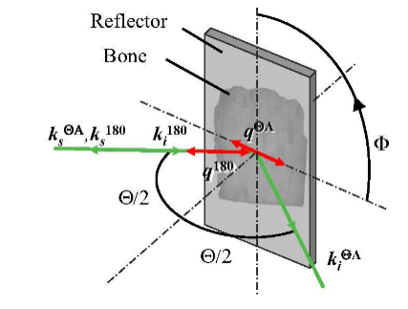

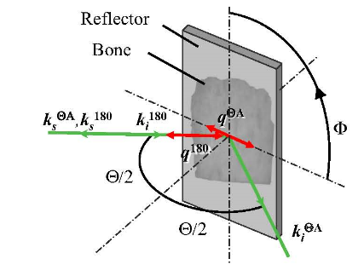(b)

**Fig.15.19** (a) An example of the Brillouin Scattering spectroscopy setup using the Tandem Fabry-Perot interferometer [110]. (b) shows the RIΘA scattering geometry near the sample. ki is the wave vector of the incident light, ks is the wave vector of the scattered light, q is the wave vector of the phonon, Θ/2 is the angle between the incident laser beam and the thin sample surface, and Φ is the sample rotation angle in the plane.

For Brillouin spectroscopy of bone, the optical geometry and sample transparency are important. Figure 15.19 (b) shows examples of the geometry used. In case of backscattering (i.e., scattering at 180o from the incident beam) measurements, the wave vector *q*180 can be observed and the scattering light is comparatively strong. However, the effects of refractive index *n* in obtaining wave velocity must be considered as shown in Equation 5 below. On the other hand, in the reflection induced  angle (RIA) geometry [111], the interaction between incident and scattered light enables the measurement of longitudinal and shear phonons that propagate in each direction of the wave vectors *q*A and *q*180 in one measurement. Here, the wave velocity of *q*A is measured in the area where incident and reflected lights interfere near the mirror. In addition, the wave velocities can be obtained without being affected by the effects of refractive index. These optical systems can integrate a microscope (-Brillouin scattering: -BR) and enable measurement of the scattering from a minute area (diameter of several m) as shown in the figure.

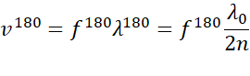

(5)

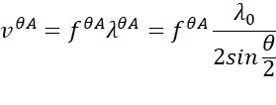

(6)

To obtain sufficient transparency for RIA measurements, thin plate specimens (30–150 m) must be prepared carefully without embedding in the resin. These specimens should align parallel or perpendicular to the bone axis in the cortical bone. In case of trabecular bone, the trabecular bone cube was first fabricated and the structure was evaluated by a high-resolution X-ray computed tomography. From the 3D reconstructed image, the length and direction of each trabecula were obtained. Here, the longitudinal direction of the small specimen prepared from each trabecula was set parallel to the trabecular axis.

Kawabe et al., achieved site-matched measurements of wave velocity by -BR and acoustic impedance by Scanning Acoustic Microscopy (SAM) using identical bovine trabecula specimens [112]. The spatial resolutions of -BR and SAM were similar (10 and 8 m, respectively). Fig. 15.20 (a) shows the SAM image of cancellous bone and (b) shows the lines measured by Brillouin scattering. Although the measured properties were different, data showed a fairly good correlation between the wave velocity and acoustic impedance along line A (R2 = 0.63, p < 0.01) and B (R2 = 0.67, p < 0.01)(Fig.15.21). The average velocity in the trabecula was approximately 4.92×103 m/s. These values are, however, higher than the expected velocity values inferred from SAM acoustic impedance measurements in the range from 50 to 200 MHz, considering the reported mass density of bone [103]. Velocity dispersion between the MHz and GHz ranges and dry condition might be the reasons for the discrepancy as mentioned above. The heterogeneity and anisotropy in one trabecula in a bovine femur were also examined in detail using the -BR technique. The trabeculae align three dimensionally in the cancellous bone. In cancellous bone of the bovine femur, the average longitudinal wave velocities in the trabeculae aligning in the bone axis and anterior-posterior (A-P) directions were almost similar [113]. By rotating the sample, Fukui found a very weak anisotropy of longitudinal wave velocity in a trabecula [114] (Fig.15.22).

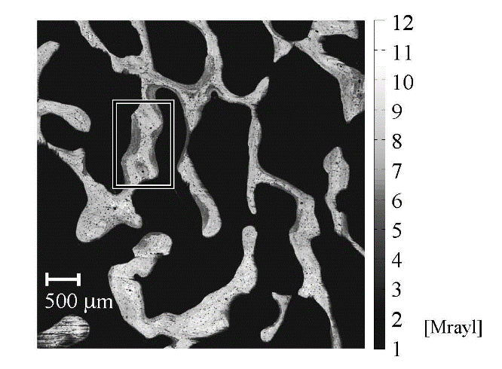

(a)

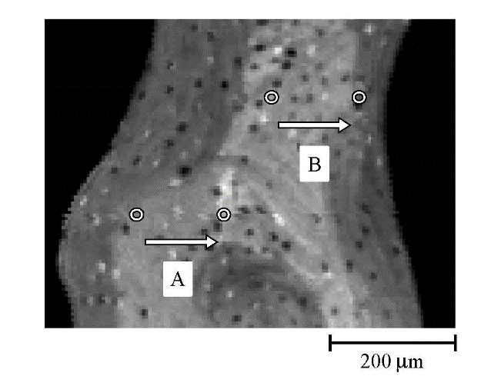

(b)

**Fig.15.20** (a) Acoustic Impedance mapping (200 MHz) of a trabecula in the distal part of a bovine femur and (b) measured area for -Brillouin scattering technique.

Cancellous bone in the bovine femur is often made of porous plates-like trabeculae (in the bone axis and A-P directions) and connecting short trabecular rods in the medial-lateral direction. Figure 15.23 showing the relationship between trabecular length and velocity, suggests that the velocity tends to decrease in longer trabeculae [115]. Moreover, velocity values approach 4.75×103 m/s, suggesting the existence of a minimum value. Therefore, this means that the velocity depended on the type of structure (plate- or rod-like) because the velocity values in the A-P and axis directions were comparatively small. The longitudinal wave velocities reflect elastic properties. These data suggest that the microscopic elastic properties of trabeculae depend strongly on their structure and alignment direction.

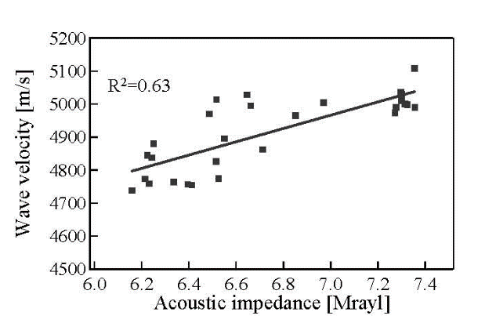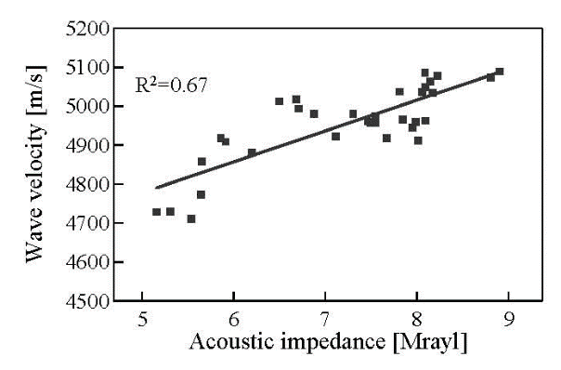

**Fig.15.21** The site matched correlations between SAM and -BR data at lines A and B.

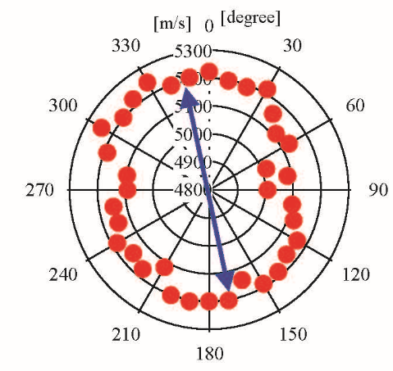

**Fig.15.22** Anisotropy of longitudinal wave velocity in a trabecula of bovine femur. The arrow indicates the maximum velocity direction. Trabecular alignment direction: 0 to 180 degrees. (Reprinted with permission from Ref. [114] copyright (2014), Elsevier)

-BR can also be applied to bone material characterization. In a series of papers, Haïat et al., have combined nano-indentation measurements and micro-Brillouin scattering measurements in order to estimate the difference of biomechanical properties between newly formed and mature rabbit bone tissues at the vicinity of an implant [116, 117]. The wave velocity measured by -BR gradually increased as a function of healing time and to finally reach the values of mature bone. A similar tendency was observed with nano-indentation measurements.

Wave velocity in bone also depends on the condition of hyperglycemia diabetes. Yasui et al, measured the wave velocity in tibias of Spontaneously Diabetic Torii (SDT) rats using -BR [118]. They pointed out that before the onset of diabetes (aged approximately 10 weeks), SDT rat bones displayed wave velocities similar to healthy Sprague-Dawley (SD) rat bones. By contrast, after the onset of hyperglycemia diabetes (aged above 20 weeks), the mean velocities of SDT rat bones were lower than those of SD rat bones (by 2% in cortical bone and 4.0% in cancellous bone) (p<0.05) (Fig.15.24). The data show that the wave velocity decreased in young rat bone during the early stages of diabetes. Patients with diabetes are known to frequently display altered bone structure and material properties, low bone formation, increased cortical porosity, and decreased bone turnover, leading to impaired bone quality [119-121]. Yasui et al. pointed out that the elasticity of the bone matrices might also decrease due to the diabetes.



1. (b)

**Fig.15.23** (a) an example of the specimen and (b) relationship between longitudinal wave velocity and trabecular length (filled markers indicate data for a 29-month-old specimen; other markers indicate data for a 31-month-old specimen). The sliced samples (thickness around 130 m) were obtained from the distal end of the bovine femora and velocities were averaged values of measured data in one trabecula.

The intensity of the backscattered (180o) light is stronger than that from the RIA scattering geometry. Cardinali et al, assessed the distribution of the frequency shift in cartilage, subchondral bones and trabecular bones of a human femoral head (Fig.15.25) which was removed as a result of focal severe osteoarthritis (OA) [122]. A specimen of 1 cm in thickness and 1 cm in width was collected from the inferomedial region of the femoral head which was a healthy site. Measurements were performed using a -BR system with high spatial resolution (2 mm) at random on the cartilage surface. Subchondral and trabecular bones had given evidence of marked mechanical heterogeneity. In all the investigated regions, strong bimodal spectra had been observed, which were due to the coexistence of soft (4.3 GPa) and hard (16 and 25 GPa) regions within the few micrometers of the scattering volume. Here, they assumed constant values in the sample for the refractive indices (*n* = 1.55) and density (2000 kg/m3) [123]. The soft component can be attributed to the amorphous fraction of the bone. The hard region can be identified with mineralized collagen fibrils. Using the conventional tandem Fabry-Perot system, Akilbekova et al. investigated also the effects of compression on bone using mammalian bones. [110]

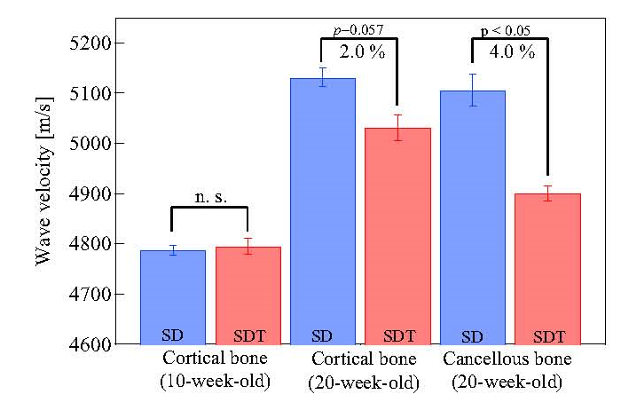

**Fig.15.24** Averaged wave velocities of cortical and cancellous bones in 10- and 20-week SD and SDT rats (error bar: standard deviation). (Reprinted with permission from Ref. [118] copyright (2020), Springer nature)

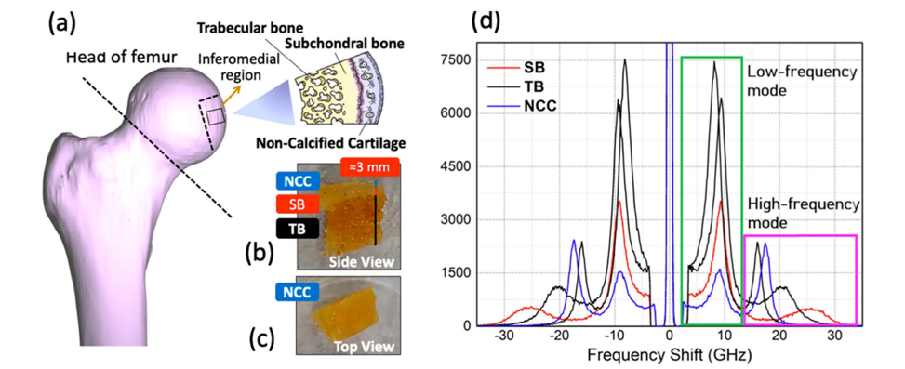

**Fig. 15.25** (a) 3D rendering image of a human femoral head with the site of inferomedial region from which the sample was selected. (b) Longitudinal section of the sample with subchondral bone (SB) and trabecular bone (TB). (c) Top view of the same section, showing the articular non-calcified cartilage surface (NCC). (d) Typical Brillouin spectra collected from cartilage surface (blue), subchondral bone 8red) and trabecular bone (black).

The tandem multi-pass Fabry-Perot interferometer is suitable for the measurement of bulk phonons with high contrast and resolution. Recently, virtually imaged phased array (VIPA) spectrometers have been developed and VIPA-Brillouin microscopy [50] has been applied to the life sciences. VIPA system can reduce the measurement time of a single spectrum by a factor of 100-1000, however, it still suffers from a poor contrast. The development of this system may provide a lot of information on bone properties in the future [124].

**15.4.3 Conclusion**

This chapter has discussed recent studies on bone material characterization, focusing on piezoelectricity and opto-acoustic measurements. These two topics seem to be a little deviated, however, they have common characteristics that the obtained properties do not depend only on the viscoelasticity like in conventional ultrasonic material characterization. Considering that there occur a lot of physical phenomena in the living body, the electric and optical properties of bone may become important factors for the future diagnosis. One interesting topic is the non-contact evaluation of bone piezoelectricity by the ASEM method. Since the piezoelectricity depends on the collagen in bone, non-contact evaluation of collagen degradation may become possible by the piezoelectric evaluation.

Photoacoustic studies are also targeting non-contact evaluation of bone from outside of the body. Some photoacoustic bone evaluations are often similar to some conventional ultrasonic techniques wherein ultrasonic waves propagating in the bone like guided waves are measured, except for the conventional techniques of ultrasound generation and detection. However, considering the process of ultrasound generation by the photoacoustic phenomenon, the techniques may reveal new material properties in bone, because, for example, ultrasound is generated due to the light absorption in the blood cell and collagen. It means that the evaluation of generated ultrasound gives us tissue information.

These non-contact evaluation techniques will open another window for the future evaluation of bone.

**References**

[1] I. Yasuda, K. Noguchi, T. Sata, Dynamic callus and electric callus, J. Bone Joint Surg. 37-A, 1292-1293, 1955.

[2] I. Yasuda, Mechanical and electrical callus, Ann. N. Y. Acad. Sci. 238(1), 457-465, 1974.

[3] E. Fukada and I. Yasuda, On the piezoelectric effect of bone, J. Phys. Soc. Jpn. 12(10), 1158-1162, 1957.

[4] C. A. L. Bassett, Biophysical principles affecting bone structure, The Biochemistry and Physiology of Bone, Ed. G. Bourne (Academic Press, New York, 1971), 1-76.

[5] A. Gjelsvik, Bone remodeling and piezoelectricity - I, J. Biomech. 6(2), 69-77, 1973.

[6] N. Guzelsu, A piezoelectric model for dry bone tissue, J. Biomech. 11, 257-267, 1978.

[7] E. Fukada, Piezoelectricity of Wood, J. Phys. Soc. Jpn. 10, 149-154, 1955.

[8] C. A. L. Bassett and R. O. Becker, Generation of electric potentials by bone in response to mechanical stress, Science 137, 1063-1064, 1962.

[9] M. H. Shamos, L. S. Lavine, and M. I. Shamos, Piezoelectric effect in bone, Nature 5, 81, 1963.

[10] E. Fukada and I. Yasuda, Piezoelectric effects in collagen, Jpn. J. Appl. Phys. 3(2), 117-121, 1964.

[11] M. H. Shamos and L. S. Lavine, Piezoelectricity as a fundamental property of biological tissues, Nature 213, 267-269, 1967.

[12] A. A. Marino, R. O. Becker, and S. C. Soderholm, Origin of the piezoelectric effect in bone, Calcif. Tissue Res. 8(1), 177-180, 1971.

[13] S. A. M. Tofail, D. Haverty, F. Cox, J. Erhart, P. Hána, and V. Ryzhenko, Direct and ultrasonic measurements of macroscopic piezoelectricity in sintered hydroxyapatite, J. Appl. Phys. 105(6), 064103, 2009.

[14] S. B. Lang, S. A. M. Tofail, A. A. Gandhi, M. Gregor, C. Wolf-Brandstetter, J. Kost, S. Bauer, and M. Krause, Pyroelectric, piezoelectric, and photoeffects in hydroxyapatite thin films on silicon, Appl. Phys. Lett. 98, 123703, 2011.

[15] G. V. B. Cochran, R. J. Pawluk, and C. A. L. Bassett, Electromechanical characteristics of bone under physiologic moisture conditions, Clin. Orthop. Relat. Res. 58, 249-270, 1965.

[16] J. C. Anderson and C. Eriksson, Piezoelectric properties of dry and wet bone, Nature 227, 491-492, 1970.

[17] A. J. Bur, Measurements of the dynamic piezoelectric properties of bone as a function of temperature and humidity, J. Biomech. 9(8), 495-507, 1976.

[18] H. Maeda, K. Tsuda, and E. Fukada, The dependence on temperature and hydration of piezoelectric, dielectric and elastic constants of bone, Jpn. J. Appl. Phys. 15(12) 2333-2336, 1976.

[19] H. Maeda and E. Fukada, Effect of water on piezoelectric, dielectric, and elastic properties of bone, Biopolymers 21(10), 2055-2068, 1982.

[20] M. W. Johnson, D. A. Chakkalakal, R. A. Harper, and J. L. Katz, Comparison of the electromechanical effects in wet and dry bone, J. Biomech. 13(5), 437-442, 1980.

[21] D. Gross and W. S. Williams, Streaming potential and the electromechanical response of physiologically-moist bone, J. Biomech. 15(4), 277-295, 1982.

[22] M. Otter, J. Shoenung, and W. Williams, Evidence for different sources of stress-generated potentials in wet and dry bone, J. Orthop. Res. 3(3), 321-324, 1985.

[23] G. W. Hastings and F. A. Mahmud, The electromechanical properties of fluid-filled bone: A new dimension, J. Mater. Sci.: Mater. Med. 2(2), 118-124, 1991.

[24] A. A. Marino and R. O. Becker, Piezoelectricity in hydrated frozen bone and tendon, Nature 253, 627-628, 1975.

[25] J. H. McElhaney, The charge distribution of the human femur due to load, J. Bone Joint Surg. 49-A(8), 1561-1571, 1967.

[26] W. Starkebaum, S. R. Pollack, and E. Korostoff, Midroelectrode studies of stress-generated potentials in four-point bending of bone, J. Biomed. Mat. Res. 13(5), 729-751, 1979.

[27] G. Aschero, P. Gizdulich, and F. Mango, Statistical characterization of piezoelectric coeffcient d23 in cow bone, J. Biomech. 32(6), 573-577, 1999.

[28] C. Halperin, S. Mutchnik, A. Agronin, M. Molotskii, M. Salai, and G. Rosenman, Piezoelectric effect in human bones studied in nanometer scale, Nano Lett. 4(7), 1253-1256, 2004.

[29] M. M. Jolandan and M. F. Yu, Shear piezoelectricity in bone at the nanoscale, Appl. Phys. Lett. 97, 153127, 2010.

[30] A. A. Marino and R. O. Becker, Piezoelectricity in bone as a function of age, Calcif. Tissue Res. 14(1), 327-331, 1974.

[31] G. Aschero, P. Gizdulich, F. Mango, and S. M. Romano Converse piezoelectric effect detected in fresh cow femur bone, J. Biomech. 29(9), 1169-1174, 1996.

[32] C. A. M. Xavier and L. R. Duarte, Ultrasonic stimulation of bone callus: Clinical applications, Rev. Brasileira Orthp. 18(3), 73-80, 1983.

[33] L. R. Duarte, The stimulation of bone growth by ultrasound, Arch. Orthop. Trauma Surg. 101, 153-159, 1983.

[34] J. Behari and S. Singh, Ultrasound propagation in 'in vivo' bone, Ultrasonics 19(2), 87-90, 1981.

[35] M. Okino, S. Coutelou, K. Mizuno, T. Yanagitani, and M. Matsukawa, Electrical potentials in bone induced by ultrasound irradiation in the megahertz range, Appl. Phys. Lett. 103(10), 103701, 2013.

[36] H. Tsuneda, S. Matsukawa, S. Takayanagi, K. Mizuno, T. Yanagitani, and M. Matsukawa, Effects of microstructure and water on the electrical potentials in bone induced by ultrasound irradiation, Appl. Phys. Lett. 106(7), 073704, 2015.

[37] S. Matsukawa, T. Makino, S. Mori, D. Koyama, S. Takayanagi, K. Mizuno, T. Yanagitani, and M. Matsukawa, Effect of anisotropy on stress-induced electrical potentials in bovine bone using ultrasound irradiation, Appl. Phys. Lett. 110(14), 143701, 2017.

[38] S. Mori, T. Makino, D. Koyama, S. Takayanagi, T. Yanagitani and M. Matsukawa, Ultrasonically-induced electrical potentials in demineralized bovine cortical bone, AIP Adv. 8(4), 0450007, 2018.

[39] T. Makino, T. Nakamura, L. Bustamante, S. Takayanagi, D. Koyama and M. Matsukawa, Piezoelectric and inversely piezoelectric responses of bone tissue plates in the megahertz range, IEEE Trans. Ultrason. Ferroelectr. Freq. Control 67(8), 1525-1532, 2020.

[40] A. Hosokawa, Investigation of piezoelectric anisotropy of bovine cortical bone at an ultrasound frequency by coupling an experiment and a simulation, J. Acoust. Soc. Am. 142(2), EL184-EL189, 2017.

[41] K. Ikushima, S. Watanuki, and S. Komiyama, Detection of acoustically induced electromagnetic radiation, Appl. Phys. Lett. 89(19), 194103, 2006.

[42] K. Ikushima, T. Kumamoto, K. Ito, and Y. Anzai, Electric polarization of soft biological tissues induced by ultrasound waves, Phys. Rev. Lett. 123(23), 238101, 2019.

[43] P. Güthner, and K. Dransfeld, Local poling of ferroelectric polymers by scanning force microscopy, Appl. Phys. Lett. 61(9), 1137-1139, 1992.

[44] A. Hosokawa, Experimental observation of piezoelectric effect in cancellous bone generated by ultrasound irradiation, J. Acoust. Soc. Am. 140(5), EL441-EL445, 2016.

[45] A. Hosokawa, Change of piezoelectric signal in cancellous bone with ultrasound irradiation angle, Jpn. J. Appl. Phys. 59, SKKE03, 2020.

[46] A. Hosokawa, Numerical simulation of piezoelectric effect of bone under ultrasound irradiation, Jpn. J. Appl. Phys. 54, 07HF06, 2015.

[47] A. Hosokawa, Numerical simulation of piezoelectric effect under ultrasound irradiation with consideration of conductivity, Jpn. J. Appl. Phys. 55, 07KF03, 2016.

[48] A. Hosokawa, Observations of experimental and numerical waveforms of piezoelectric signals generated in bovine cancellous bone by ultrasound waves, Jpn. J. Appl. Phys. 57, 07LF06, 2018.

[49] J. R. Sandercock, In: Light scattering in solids III, Topics in Applied Physics vol.51 (M. Cardona and G. Guntherodt, eds), 173-206, Springer, Berlin.

[50] G. Scarcelli, S. H. Yun, Confocul Brillouin Microscopy for three-dimensional mechanical imaging, Nat. Photonics, 2008, 2, 39-43.

[51] G. Scarcelli, S. H. Yun, In vivo Brillouin optical microscopy of the human eye, Opt. Express, 2012, 20, 9197-9202.

[52] A. G. Bell, Am. J. Sci, 20. 305.

[53] D. A. Hutchins, A. C. Tam, Pulsed Photoacoustic Materials Characterization, IEEE TUFFC, UFFC-33, (5), 429-449(1986).

[54] A. C. Tam, Applications of photoacoustic sensing techniques, Rev. Mod. Phys., 58, (2), 381-431.

[55] L. B. Kreuzer, Ultralow Gas Concentration Infrared Absorption Spectroscopy, J. Appl. Phys., 42, 2934-2943 (1971).

[56] A. K. Thella, J. Rizkalla, A. Helmy, V. K. Suryadevara, P. Salama, M. Rizkalla, Non-invasive photo acoustic approach for human bone diagnosis, J. Orthopaedics, 13, 394-400 (2016).

[57] A. Rosencwaig, Photoacoustic Spectroscopy of Biological materials, Science, 181, 657-658 (1973).

[58] A. Rosencwaig, A. Gersho, Theory of the photoacoustic effect with solids, J. Appl. Phys., 47(1), 64-69 (1976).

[59] A.B.E. Attia, G. Balasundaram, M. Moothanchery, U.S. Dinish, R. Bi, V. Ntziachristos, M. Olivo, A review of clinical photoacoustic imaging: Current and future trends, Photoacoustics, 16, 100144 (2019).

[60] P. A. Lomelí, Mejia, G. Urriolagoítia, J.L.Jiménez Pérez, L.H. Hernández Gomez, H. Lecona Butron, A. Cruz Orea, Photoacoustic Spectroscopy applied to the study of bone consolidation in fractures, Materials Science Forum, Vols, 480-481, 339-344 (2005).

[61] P. A. Lomelí Mejia, J. L. Jiménez Pérez, A. Cruz Orea, H. Villegas Castrejón, H. Lecona Butron, M. Melédez lira, Photoacoustic analysis of bone osteogenesis to different doses of laser irradiation, J. Vac. Sci. Technol. A 23(4), 761-763 (2005).

[62] M. Xu, L. V. Wang, Photoacoustic imaging in biomedicine, Rev. Sci. Instr. 77, 041101 (2006)

[63] M. Kneipp, J. Turner, H. Estrada, J. Rebling, S. Shoham, D. Razansky, Effects of the murine skull in optoacoustic brain microscopy, J. Biophotonics, 9, No.1-2, 117-123 (2016).

[64] C. G. Parigger, J. A. Johnson, R. Splinter, Physiological sensing through tissue with femto-second laser radiation, Proc. IEEE IUS, p.197-201(2012).

[65] L. V. Wang, Prospects of photoacoustic tomography, Medical Physics, 35 (12), 5758-5767 (2008).

[66] T. Li, R. J. Dewhurst, Photoacoustic imaging in both soft and hard biological tissue, J. Phys, Conference series, 214, 012028 (2010).

[67] A. Sampathkumar, D. A. Hughes, K. J. Kirk, W. Otten, C. Longbottom, All-optical photoacoustic imaging and detection of early-stage dental caries, Proc. IEEE IUS, 1269-1272 (2014).

[68] B. Lashkari, A. Mandelis, Combined photoacoustic and ultrasonic diagnosis of early bone loss and density variations, Proc. SPIE, Vol.8207, 82076K (2012).

[69] B. Lashkari, A. Mendelis, Coregistered photoacoustic and ultrasonic signatures of early bone density variations, J. Biomed. Opt. 19(3), 036015 (2014).

[70] L. Yang, B. Lashkari, J. W. Y. Tan, A. Mandelis, Photoacoustic and ultrasound imaging of cancellous bone tissue, J. Biomed. Opt., 20 (7), 076016 (2015).

[71] B. Lashkari, L. Yang, A. Mendelis, The application of backscattered ultrasound and photoacoustic signals for assessment of bone collagen and mineral contents, Quant Imaging Med Surg. 5(1), 46-56 (2015).

[72] T. Feng, K. M. Kozloff, C. Tian, J. E. Perosky, Y.-S. Hsiao, S. Du, J. Yuan, C. X. Deng, X. Wang, Bone assessment via thermal photo-acoustic measurements, Optics Letters, Vol.40, (8), 1721-1724 (2015).

[73] T. Feng, J. E. Peroski, K. M. Kozloff, G. Xu, Q. Cheng, S. Du, J. Yuan, C. X. Deng, X. Wang, Characterization of bone microstructure using photoacoustic spectrum analysis, Optics Exp. 23 (19), 246083 (2015).

[74] T. Feng, K. Kozloff, Y.-S. Hsiao, G. Xu, S. Du, Photoacoustic imaging: a potential new platform for assessment of bone health, Proc. SPIE, Vol.9303, 93033 (2015).

[75] T. Feng, Y. Zhu, C. Liu, W. Xie, D. Ta, X. Wang, Q. Cheng, The feasibility study of the photoacoustic signa; detection in human calcaneous bone in vivo, Abtsract of IEEE IUS, (2020).

[76] P. Moilanen, P. Karppinen, T. Karppinen, Z. Zhao, M. Myllyla, E. Hӕggström, J. Timonen, Photo-acoustic excitation and detection of fundamental antisymmetric Lamb mode in coated bone phantoms, J. Acoust. Soc. Am., 131, 3426 (2012).

[77] P. Moilanen, Z. Zhao, P. Karppinen, T. Karppinen, V. Kilappa, J. Pirhonen, R. Myllylä, E. Hӕggström, J. Timonen, Photo-acoustic excitation and optical detection of fundamental flexural guided wave in coated bone phantom, Ultrasound in Med. & Biol. 40 (3), 521-531 (2014).

[78] P. Moilanen, M. Talmant, P.H.F. Nicholson, S. Cheng, J. Timonen, P. Laugier, Ultrasonically determined thickness of long cortical bones: Three-dimensional simulations of in vitro experiments. J. Acoust. Soc. Am., 122, 2439-2445 (2007).

[79] P. Moilanen, Ultrasonic guided waves in bone, IEEE Trans. Ultrasoni Ferroelectr. Freq. Contr. 55, 1277-1285 (2008).

[80] I. Steinberg, A. Eyal, I. Gannot, Multispectral photoacoustic method for the early detection and diagnosis of osteoporosis, Proc. SPIE, 8565, 85656G (2013).

[81] I. Steinberg, N. Turko, O. Levi, I. Gannot, A. Eyal, Quantitative study of optical and mechanical bone status using multispectral photoacoustics, J. Biophotonics, 9, 924-933 (2016).

[82] I. Steinberg, L. Shiloh, I. Gannot, A. Eyal, First-in-human study of bone pathologies using low-cost and compact dual-wavelength photoacoustic system, IEEE J. Selected Topics in Quantum Electronics, 25(1), 7201908 (2019).

[83] M. Kawai, F.J.A. de Paula, C.J. Rosen, New insights into osteoporosis: The bone-fat connection, J. Internal. Med. 272 (4), 317-329 (2012).

[84] J. Shubert, M. A. L. Bell, Photoacoustic imaging of a human vertebra: implications for guiding spinal fusion surgeries, Phys. Med. Biol. 63, 144004 (2018).

[85] J. A. Merrill, S. Wang, Y. Zhao, J. Arellano, L. Xiang, Photoacoustic microscopy for bone microstructure analysis, Proc. SPIE, 11241, 112410H (2020).

[86] P. Laugier, G. Haïat eds, Bone Quantitative Ultrasound, Springer (2011).

[87] R. B. Martin, D. B.Burr, N.A. Sharkey, D.P. Fyhrie, Skeletal tissue mechanics 2nd ed., Springer (2015).

[88] F.L. Susan, J.L. Katz, The relationship between elastic properties and microstructure of bovine cortical bone, J. Biomech., 17, 241-249 (1984).

[89] R. Lakes, H.S. Yoon, J.L.Katz, Ultrasonic wave propagation and attenuation in wet bone, J. Biomech. Eng., 8, 143-148 (1986).

[90] Y. Yamato, M. Matsukawa, T. Otani, K. Yamazaki, A. Nagano, Distribution of longitudinal wave properties in bovine cortical bone in vitro, Ultrasonics, 44, e233-e237 (2006).

[91] I. Jäger, P. Fratzl, Mineralized collagen fibrils: a mechanical model with a staggered arrangement of mineral particles. Biophys. J. 79, 1737–1746 (2000).

[92] P. Fratzl, H. S. Gupta, E. P. Paschalis, P. Roschger, Structure and mechanical quality of the collagen–mineral nano-composite in bone. J. Mater. Chem. 14, 2115–2123 (2004).

[93] J.P. Nightingale, D. Lewis D, Pole figures of the orientation of apatites in bones. Nature, 232, 334–335 (1971).

[94] H. L. Chen, A. A. Gundjian, Determination of the bone-crystallites distribution function by X ray diffraction. Med. Biol. Eng., 14, 531–536 (1974).

[95] N. Sasaki, Y. Sudoh, X-ray pole figure analysis of apatite crystals and collagen molecules in bone. Calcif. Tissue Int., 60, 361–367 (1997).

[96] T. Nakano, K. Kaibara, Y. Tabata, N. Nagata, S. Enomoto, E. Marukawa, Y. Umakoshi, Unique alignment and texture of biological apatite crystallites in typical calcified tissues analyzed by microbeam X-ray diffractometer system. Bone, 31, 479–487 (2002).

[97] P. Frantzl, M. Groschner, G. Vogl, H. Plenk, J. Eschberger, N. Frantzl-Zelman, K. Koller, K. Klaushofer, Mineral crystals in calcified tissues: a comparative study by SAXS. J Bone Miner. Res., 7, 329–334 (1992).

[98] S. Rinnerthaler, P. Roschger, H.F. Jakobs, K. Klausshofer, P. Frantzl, Scanning small angle X-ray scattering analysis of human bone sections. Calcif. Tissue Int. 64, 422–429 (1999).

[99] Y. Yamato, M. Matsukawa, T. Yanagitani, K. Yamazaki, H. Mizukawa, A. Nagano, Correlation between Hydroxyapatite Crystallite orientation and ultrasonic wave velocities in bovine cortical bone, Calcif. Tissue int., 82, 162-169 (2008).

[100] Y. Yamato, M. Matsukawa, H. Mizukawa, T. Yanagitani, K. Yamazaki, A. Nagano, IEEE, Trans. Ultrason. Ferroelectr. Freq. Cont., 55 (6), 1298-1303 (2008).

[101] K. Yamamoto, Y. Yaoi, Y. Yamato, T. Yanagitani, M. Matsukawa, K. Yamazaki, Ultrasonic wave properties in bone axis direction of bovine cortical bone, Jpn. J. Appl. Phys., 47 85), 4096-4100 (2008).

[102] S. Kawasaki, R. Ueda, A. Hasegawa, A. Fujita, T. Mihata, M. Matsukawa, M. Neo, Ultrasonic wave properties of human bone marrow in the femur and tibia, JASA Exp. Lett., 138 (1), EL83-EL87 (2015).

[103] K. Raum, Microelastic Imaging of bone, IEEE, Trans. Ultrason. Ferroelectr. Freq. Cont., 55 (7), 1417-1431 (2008).

[104] L. Brillouin, Diffusion de la lumière et des rayons X par un corps transparent homogène, Ann. Phys., 9 (17), 88-122 (1922).

[105] L. I. Mandelstam, Light scattering by inhomogeneous media, Zh. Russ. Fiz-Khim. Ova. 58, 381 (1926).

[106] R. Harley, D. James, A. Miller, J.W. White, Phonons and the elastic moduli of collagen and muscle, nature, 267, 285-287 (1977).

[107] S. Cusack, A. Miller, Determination of the elastic constants of collagen by Brillouin light scattering, J. Mol. Biol. 135, 39-51 (1979).

[108] G. Scarcelli, S.H. Yun, In vivo Brillouin optical microscopy of the human eye, Opt. Exp., 20 (8), 9197-9202 (2012).

[109] S. Lees, N. -J. Tao, S. M. Lindsay, Sonic velocities in bone at 10 GHz range, Acoust. Imag., 17, 371-380 (1989).

[110] D. Akilbekova, V. Ogay, T. Yakupov, M. Sarsenova, B. Umbayev, A. Nurakhmetov, K. Tazhin, V. V. Yakovlev, Z. N. Utegulov, J. Biomedical Optics, 23(9), 097004 (2018).

[111] J. K. Krüger, J. Embs, J. Brierley, R. Jimenez, A new Brillouin scattering technique for the investigation of acoustic and opto-acoustic properties: application to polymers, J. Phys. D 31, 1913-1917 (1998).

[112] M. Kawabe, K. Fukui, M. Matsukawa, M. Granke, A. Saïed, Q. Grimal, P. Laugier, Comparative investigation of elastic properties in a trabecula using micro-Brillouin scattering and scanning acoustic microscopy, JASA Exp. Lett. 132 (1), EL54-EL60 (2012).

[113] M. Kawabe, M. Matsukawa, N. Ohtori, Measurement of wave velocity distribution in a trabecula by micro-Brillouin scattering technique, Jpn. J. Appl. Phys., 49, 07HB05 (2010).

[114] K. Fukui, M. Matsukawa, Evaluation of velocity anisotropy in bovine trabecula by micro-Brillouin scattering, Proc. Forum Acusticum, 2841-2844 (2011).

[115] R. Tsubota, K. Fukui, M. Matsukawa, Local ultrasonic wave velocities in trabeculae measured by micro-Brillouin scattering, JASA Exp. Lett., 135 (2), EL109-114 (2014).

[116] V. Mathieu, K. Fukui, M. Matsukawa, M. Kawabe, R. Vayron, E Soffer, F. Anagnostou, G. Haïat, Micro-Brillouin scattering measurements in mature and newly formed bone tissue surrounding an implant, J. Biomech. Eng., 133, 021006 (2011).

[117] R. Vayron, M. Matsukawa, R. Tsubota, V. Mathieu, E. Barthel, G. Haiat, Evolution of bone biomechanical properties at the micrometer scale around titanium implant as a function of healing time, Phys. Med. Biol., 59, 1389-1406 (2014).

[118] H. Yasui, K. Yano, Y. Kuzuhara, M. Ikegawa, M. Matsukawa, Prolonged Hyperglycemia reduces elasticity of type II diabetic rat bone, Calcif. Tissue. Int. 107, 381-388 (2020).

[119] J.S. Manavalan, S. Cremers, D.W. Dempster, H. Zhou, E. Dworakowski, A. Kode, S. Kousteni, M. R. Rubin, Circulating osteogenic precursor cells in type 2 diabetes mellitus. J Clin Endocrinol Metab 97(9), 3240–3250 (2012).

[120] H. Katrine, S. Jakob, L. L. Bente, Diabetes and bone. Osteoporos Sarcopenia 5(2), 29–37 (2019).

[121] J.M. Patsch, A.J. Burghardt, S. P. Yap, T. Baum, A. V. Schwartz, G. B. Joseph, T. M. Link, Increased cortical porosity in type 2 diabetic postmenopausal women with fragility fractures. J. Bone Miner Res 28(2), 313–324 (2013).

[122] M. A. Cardinali, D. Dallari, M. Govini, C. Stagni, F. Marmi, M. Tschon, S. Brogini, D. Fioretto, A. Morresi, Brillouin micro-spectroscopy of subchondral, trabecular bone and articular cartilage of the human femoral head, Biomedical Optics express, 10 (5), 2606 (2019).

[123] I. M. Berke, J. P. Miola, M. A. David, M. K. Smith, C. Price, Seeing through Musculoskeletal Tissues:Improving In Situ Imaging of Bone and the Lacunar Canalicular System through Optical Clearing, PLoS One, 11(3), e0150268 (2016).

[124] F. Palombo, D. Fioretto, Brillouin light scattering: Applications in biomedical sciences, Chemical reviews, 119, 7833-7847 (2019).

1. M. Matsukawa (✉)

   Doshisha University, 1-3 Tatara, Miyakodani, 610-0321 Kyotanabe, Japan

   e-mail: mmatsuka@mail.doshisha.ac.jp

   A. Hosokawa

   National Institute of Technology, Akashi College, 679-3 Nishioka, Uozumi, 674-8501, Akashi, Japam

   e-mail: hosokawa@akashi.ac.jp